**BACTERIAL CONCRETE**

.

G RAJESH M.AJAY

B.TECH II year II SEM B.TECH II year II SEM

DEPARTMENT OF CIVIL ENGINEERING DEPARTMENT OF CIVIL ENGINEERING ENGINEERING

SREE VISVESVARAYA INSTITUTE OF SREE VISVESVARAYA INSTITUTEOF

TECHNOLOGY AND SCIENCE TECHNOLOGY AND SCIENCE

**ABSTRACT**

The paper presents the latest research of producing concrete with the help of bacteria.

As a part of metabolism , these bacteria promotes calcite precipitation forming CaCO3 ---which acts as binding material.

So it can be used as sealant in crack remediation ,for sand & dyke consolidation etc.

This research has been introduced by “Dr. Ramakrishnan, Sookie Bang & Ramesh Panchalan.”

**INTRODUTION:**

* The paper presents the research done by American scientists that tells us how bacteria can produce a cement !
* When these bacteria are injected in sand, they form a natural layer of cement around each individual grain.
* The fact is that microbial metabolic activities promote calcite precipitation which acts as binding material.

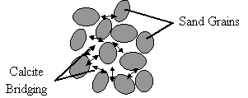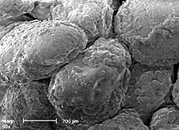

PRINCIPLE

As a part of metabolism, B.Pasteruii produces urease which catalyzes urea to produce CO2 & ammonia,

resulting in an increase of pH in the surroundings ,

leading to the precipitation of (Ca32+) & (CO32-) as CaCO3.

THE CHEMICAL REACTION:

Ca2+ + Cell Cell-Ca2+ . . . . (1)

Cl- + HCO3- + NH3  NH4Cl + CO32- . . (2)

Cell-Ca2+ + CO32- Cell-CaCO3

VARIOUS TYPES OF BACTERIA USED IN CONCRETE

There are various types of bacteria were used in construction area

· Bacillus pasteurii

· Bacillus sphaericus

· Escherichia coli

· Bacillus subtilis

· Bacillus cohnii

· Bacillus balodurans

· Bacillus pseudofirmus

**PREPARATION OF BACTERIAL CONCRETE**

Bacterial concrete can be prepared in two ways

· By direct application

· By encapsulation in light weight concrete

By the method of direct application bacterial spores and calcium lactate are added directly while making the concrete and mixed .Here when the crack occurs in the concrete bacterial spores broke and bacteria comes to life comes to life and feed on the calcium lactate and limestone is produced which fill the cracks.

By encapsulation method the bacteria and its food , calcium lactate ,are placed inside treated clay pellets and concrete is made. About 6% of the clay pellets are added for making bacterial concrete. When concrete structures are made with bacterial concrete, when the crack occurs in the structure and clay pellets are broken and bacterial treatment occurs and hence the concrete s healed. Minor cracks about 0.5mm width can be treated by using bacterial concrete.

Among these two methods encapsulation method is commonly used, even though it’s costlier than direct application .Bacillus bacteria are harmless to human life and hence it can be used effectively

**CHEMICAL PROCESS TO REMEDIATE CRACKS BY BACTERIA:**

Crack –penetrating water would not only dissolve calcite (CaCO3) particles present in mortar matrix ,but would also react together with atmospheric carbon dioxide with not fully hydrated lime constituents such as calcium oxide and calcium hydroxide according to the following reactions:

**APPLICATION OF BACTERIA IN CONSTRUCTION AREA:**

The use of microbial concrete in Bio Geo Civil Engineering has become increasingly popular .From enhancement in durability of cementations materials to improvement in sand properties, from repair of limestone monuments, sealing of concrete cracks to highly durable bricks, microbial concrete has been successful in one and all. This new technology can provide ways for low cost and durable roads, high strength buildings with bearing capacity, long lasting river banks, erosion prevention of loose sands and low cost durable housing. Another issue in conventional building materials is the high production of greenhouse gases and high energy consumed during production of these materials and these greenhouse gases leads to global warming. High construction cost of building materials is another drawback in such cases. These drawbacks have lead to use of novel , eco-friendly ,self-healing and energy efficient technology where microbes are used for remediation of building materials and enhancement in the durability characteristics.

12**. ADVANTAGES AND DISADVANTAGES OF BACTERIAL CONCRETE**

12.1 **ADVANTAGES:**

1. Microbial Concrete in Crack Remediation: Specimens were filled with bacteria, nutrients and sand. Significant increase in compressive strength and stiffness values as compared to those without cells was demonstrated. 2. Improvement in Compressive Strength of Concrete: Compressive strength test results are used to determine that the concrete mixture as delivered meets the requirements of the job specification .So the effect of microbial concrete on compressive strength of concrete and mortar was studied and it was observed that significant enhancement in the strength of concrete and mortar can be seen upon application of bacteria 2. Better Resistance towards Freeze- Thaw Attack Reduction: Application of microbial calcite may help in resistance towards Freeze –thaw reduction due to bacterial chemical process and also it can reduce the permeability than freezing process decreased. 4. Reduction in Permeability of Concrete: Effect of microbial concrete on permeation properties was studied by different researchers .Permeability can be investigated by carbonation tests as it is increasingly apparent that decrease in gas permeability due to surface treatments results in an increased resistance towards carbonation and chloride ingress .Carbonation is related to the nature and connectivity of the pores, with larger pores giving rise to higher carbonation depths. 5. Reduction in corrosion of reinforced concrete: application of microbial calcite may ingress and improves the life of reinforced concrete structures

**12.2 DISADVANTAGES**:

1. Cost of bacterial concrete is double than conventional concrete

2. Growth of bacteria is not good in any atmosphere and media

3. The clay pellets holding the self-healing agent comprise 20% of the volume of the concrete.

4. Design of mix concrete with bacteria here is no available any IS code or other code

5. Investigation of calcite precipitate is costly

**APPLICATIONS**

* It is mostly used as microbial sealant for cracks & fissures under the technique called MECR(i.e.microbiologically enhanced crack remediation. )
* For temporary cementation of mine tailing heaps to prevent removal by wind/water & in bore wells to prevent collapse.
* This MECR allows to “set” sand into a solid rock-type material without removal of sand from its location.
* Main advantage is that it pollution free & natural.
* In- situ Cementation of retaining walls(domestic & commercial).
* A way to fight erosion in sand-stone monuments & historic buildings.
* Also has aesthetic equivalence in monuments & historic buildings.
* It can also be used to bioremediate polluted soils containing Strontium(Sr) & Barium(Ba).
* Can be used for sectors such as tunnel-lining, structural basement walls, highway bridges, concrete floors and marine structures.
* It offers chemically identical material that can be color matched to the original material & made to retain the desired porosity.
* It is used for sand & dyke consolidation

**STRENGTH CHARACTERITSICS**:



**EFFFECT ON STIFFNESS OF CEMENT MORTER BEAMS**;

* Increasing stiffness of beams by 23.9% for 3.2mm & 14% for 9.5mm
* More effective remediation in shallower cracks than in deeper ones.

**EFFFECT ON COMPRESSIVE STRENGTH OF CEMENT MORTAR CUBES:-**

* Tested by “ Olsen compression testing machine”.
* Increased the compressive strength by approx..80% when compared to that of controlled specimens.

**EFFECT OF DIFF. CONCENTRATIONS OF BACTERIAL CELLS:-**

1. 4.3 × 108, 8.6 × 108, 4.3 × 109 cells per ml.
2. 8.6 × 108 cells per ml conc... Has found to induce maximum compressive strength & was taken as optimum concentration.
3. Higher conc.. did not give higher compressive strength values, because the greater population of bacteria did not have enough nutrients to multiply.

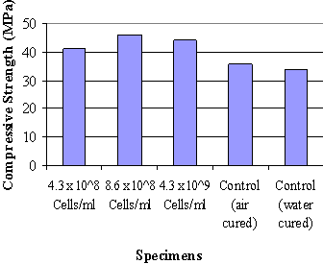

DURABILITY CHARACTERITSICS:-

The objective was to determine whether beams with bacteria performed better, when subjected to

ALKALINE, SULPHATE & FREEZE-THAW ATTACK

EFFECTS ON ALKALY AGGREGATE REACTIVITY OF CEMENT MORTAR BEAMS:-

1. with bacterial concentration of 1 x 106 cells/ml had 11% less mean expansion
2. with bacterial concentration of 1 x 107 cells/ml had 18% less mean expansion
3. with bacterial concentration of 8.6 x 108 cells/ml had 27% less mean expansion

The reduction in the mean expansion is due to the formation of calcite on the surface and interior of the specimen due to the metabolic activities of the bacteria.

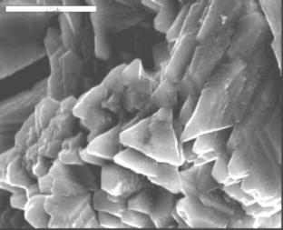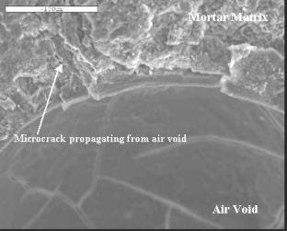

EFFECT ON SULPHATE ATTACK RESISTANCE:-

1. With bacterial concentration of 1 x 106 cells/ml had 12% less mean expansion
2. With bacterial concentration of 1 x 107 cells/ml had 38% less mean expansion
3. With bacterial concentration of 8.6 x 108 cells/ml had 39% less mean expansion
4. The reduction in the mean expansion is due to calcite precipitation which reduces permeability of specimen there by providing resistance to sulphate attack

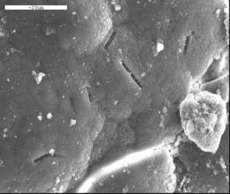

EFFECT ON THE FREEZE-THAW DURABILITY OF CEMENT MORTAR BEAMS:-

1. cement mortar beams with bacteria performed well than the beams without bacteria.
2. The higher the bacterial dosage, better was the performance.

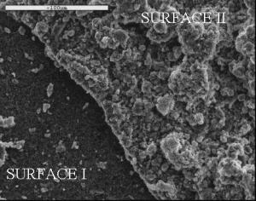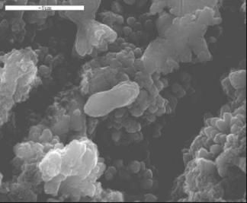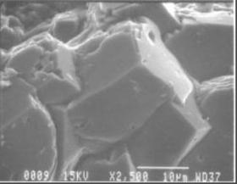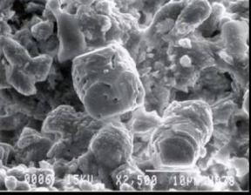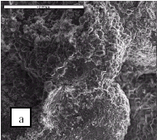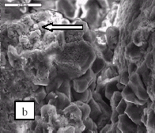

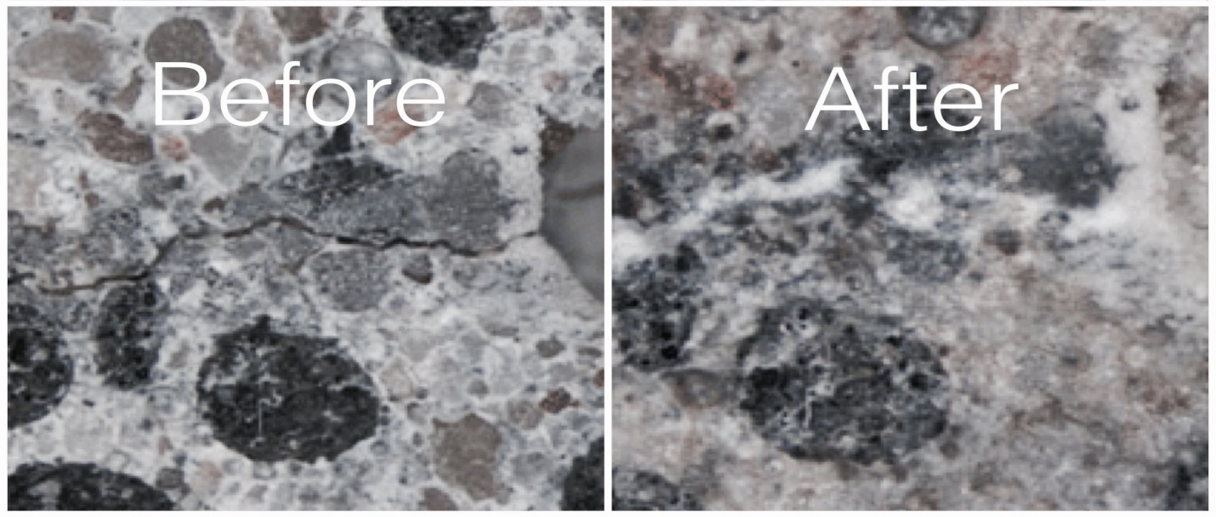

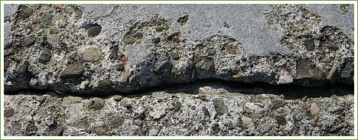 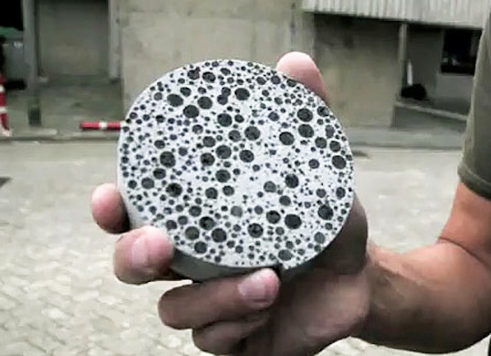

**ADVANTAGES OF BACTERIAL CONCRETE**

1. Improvement in compressive strength of concrete.

2. Better resistant towards freeze thaw attack reduction.

3. Reduction in permeability of concrete.

4. Reduction in corrosion of reinforced concrete.

5. Eco friendly.

**DISADVANTAGES OF BACTERIAL CONCRETE**

1. Cost is high.

2. Growth of bacteria is not good in any atmosphere.

3. Design of mix concrete with bacteria is not there in IS code of

any design standards.

4. Investigation if calcite precipitation layer is complex study.

5. It is great concern to know when bacteria task is complete.

6. Very limited research work is done across the globe.

**LIMITATIONS**

* Not more bacteria are known that can be used for calcite precipitation.
* Difficulties in the injection technology of the bacteria into sand.
* Extremely high pH of the concrete (above 12.5) hampers the use of bacterial cell in MECR technique.
* Controlled environment is necessary.

**FUTURE SCOPE**

* To search for more bacterial varieties that can be used for calcite precipitation.
* To overcome the problems in the injection technology of the bacteria.
* To develop recombinent microorganisms which is expected to complement the results of this study.

**CONCLUSION**

1. Bacterial concrete technology has proved to be better than many conventional technologies because of its eco- friendly nature, self-healing abilities and increase in durability of various building materials.

2. Work of various researchers has improved our understanding on the possibilities and limitations of biotechnological applications on building materials.

3. Enhancement of compressive strength, reduction in permeability, water absorption, reinforced corrosion have been seen in various cementitious and stone materials.

4. In bacterial concrete interconnectivity of pores is disturbed due to plugging of pores with calcite crystals.Since interconnected pores are significant for permeability ,the water permeability is decreased in bacteria treated specimens.

5. Cementation by this method is very easy and convenient for usage. This will soon provide the basis for high quality structures that will be cost effective and environmentally safe but, more work is required to improve the feasibility of this technology from both an economical and practical viewpoints.

6. The application of bacterial concrete to construction may also simplify some of the existing construction processes and revolutionize the ways of new construction processes.