BLOCKCHAIN

Anjum Nooreen,Sumrana Firdouse
Department of Computer Science and Engineering
Sree Visvesvaraya Institute of Technology and Science
Chowderpally,Mahaboobnagar
anjumnooreen@gmail.com,sumranafirdous13@gmail.com

Abstract:A blockchain is essentially a distributed database of records or public ledger of all transactions or digital events that have been executed and shared among participating parties. Each transaction in the public ledger is verified by consensus of a majority of the participants in the system. And, once entered, information can never be erased. The blockchain contains a certain and verifiable record of every single transaction ever made. Bitcoin, the decentralized peertopeer digital currency, is the most popular example that uses blockchain technology. The digital currency bitcoin itself is highly controversial but the underlying blockchain technology has worked flawlessly and found wide range of applications in both financial and nonfinancial world.
I.INTRODUCTION:
A blockchain is essentially a distributed database of records or public ledger of all transactions or digital events that have been executed and shared among participating parties. Each transaction in the public ledger is verified by consensus of a majority of the participants in the system. And, once entered, information can never be erased. The blockchain contains a certain and verifiable record of every single transaction ever made. To use a basic analogy, it is easy to steal a cookie from a cookie jar, kept in a secluded place than stealing the cookie from a cookie jar kept in a market place, being observed by thousands of people. Bitcoin is the most popular example that is intrinsically tied to blockchain technology. It is also the most controversial one since it helps to enable a multibillion-dollar global market of anonymous transactions without any governmental control. Hence it has to deal with a number of regulatory issues involving national governments and financial institutions. However, Blockchain technology itself is non-controversial and has worked flawlessly over the years and is being successfully applied to both financial and non-financial world applications. Last year, Marc Andreessen, the doyen of Silicon Valley’s capitalists, listed the blockchain distributed consensus model​as the most important invention since the Internet itself. Johann Palychata from BNP Paribas wrote in the Quintessence magazine that bitcoin’s blockchain, the software that allows the digital currency to function should be considered as an invention like the steam or combustion engine that has the potential to transform the world of finance and beyond.
The advantages of Blockchain technology outweigh the regulatory issues and technical challenges. One key emerging use case of blockchain technology involves “smart contracts​”. Smart contracts are basically computer programs that can automatically execute the terms of a contract. When a pre-configured condition in a smart contract among participating entities is met then the parties involved in a contractual agreement can be automatically made payments as per the contract in a transparent manner. Smart Property​is another related concept which is regarding controlling the ownership of a property or asset via blockchain using Smart Contracts. The property can be physical such as car, house, smartphone etc. or it can be non-physical such as shares of a company. It should be noted here that even Bitcoin is not really a currency- Bitcoin is all about controlling the ownership of money. Blockchain technology is finding applications in wide range of areas—both financial​and non-financial​. Financial​institutions and banks no longer see blockchain technology as threat to traditional business models. The world’s biggest banks are in fact looking for opportunities in this area by doing research on innovative blockchain applications. In a recent interview Rain Lohmus of Estonia’s LHV bank told that they found Blockchain to be the most tested and secure for some banking and finance related applications. Non-Financial​applications opportunities are also endless. We can envision putting proof of existence of all legal documents, health records, and loyalty payments in the music industry, notary, private securities and marriage licenses in the blockchain. By storing the fingerprint of the digital asset instead of storing the digital asset itself, the anonymity or privacy objective can be achieved.
II. BLOCKCHAIN TECHNOLOGY
1. Short History of Bitcoin: In year 2008, an individual or group writing under the name of Satoshi Nakamoto published a paper entitled “Bitcoin: A Peer-To-Peer Electronic Cash System”. This paper described a peer-to-peer version of the electronic cash that would allow online payments to be sent directly from one party to another without going through a financial institution. Bitcoin was the first realization of this concept. Now word cryptocurrencies is the label that is used to describe all networks and mediums of exchange that uses cryptography to secure transactions-as against those systems where the transactions are channeled through a centralized trusted entity
2. Blockchain Technology: How does it work?
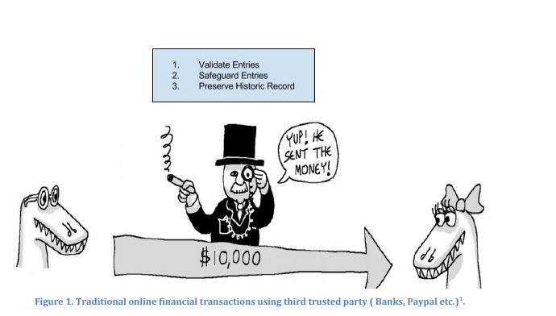Internet commerce is exclusively tied to the financial institutions serving as the trusted third party who process and mediate any electronic transaction. The role of trusted third party is to validate, safeguard and preserve transactions. A certain percentage of fraud is unavoidable in online transactions and that needs mediation by financial transactions. This results in high transaction costs. Bitcoin uses cryptographic proof instead of the trust in the third party for two willing parties to execute an online transaction over the Internet. Each transaction is protected through a digital signature. Each transaction is sent to the “public key” of the receiver digitally signed using the “private key” of the sender. In order to spend money, owner of the cryptocurrency needs to prove the ownership of the “private key”. The entity receiving the digital currency verifies the digital signature –thus ownership of corresponding “private key”--on the transaction using the “public key” of the sender. Each transaction is broadcast to every node in the Bitcoin network and is then recorded in a public ledger after verification. Every single transaction needs to be verified for validity before it is recorded in the public ledger. Verifying node needs to ensure two things before recording any transaction: 1. Spender owns the cryptocurrency digital signature verification on the transaction. 2. Spender has sufficient cryptocurrency in his/her account: checking every transaction against spender’s account (“public key”) in the ledger to make sure that he/she has sufficient balance in his/her account.

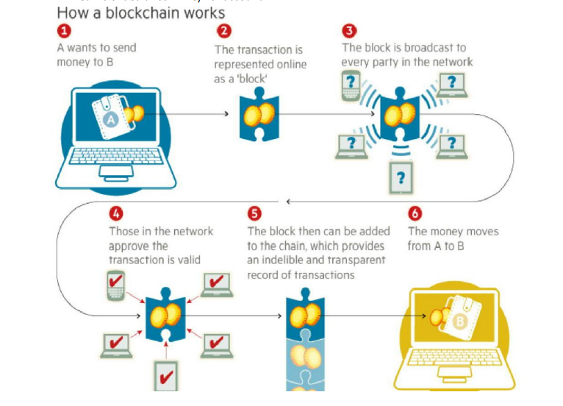
III: Applications of Technology Compelling Use Cases in both Financial and NonFinancial Areas:
1.Financial-Applications: 1.1. Private Securities :It is very expensive to take a company public. A syndicate of banks must work to underwrite the deal and attract investors. The stock exchanges list company shares for secondary market to function securely with trades settling and clearing in a timely manner. It is now theoretically possible for companies to directly issue the shares via the blockchain. These shares can then be purchased and sold in a secondary market that sits on top of the blockchain. Here are some examples:
NASDAQ Private Equity: ​NASDAQ launched its Private Equity Exchange in 2014 . This is 6 meant to provide the key functionalities like Cap table and investor relationship management for the the pre-IPO or private companies. The current process of trading stocks in this exchange is inefficient and slow due to involvement of multiple 3rd parties. NASDAQ has joined hands with a San Francisco based Start-up called chain.com to 7 implement private equity exchange on top of BlockChain. Chain.com is implementing BlockChain based smart contracts to implement exchange functionality. This product is expected to be fast, traceable and efficient.
Medici​is being developed as a securities exchange that uses the Counterparty implementations of Bitcoin 2.0. The goal here is to create a cutting edge stock market. Counterparty is a protocol that implements traditional financial instruments as the self-executing smart contracts. These smart contracts facilitate, verify or enforce the negotiation of contract and eliminate the need for a physical document. This eliminates the need for an intermediary, such as broker, exchange or bank. Blockstream ​is an open source project with focus on sidechains- interoperable blockchains- to avoid fragmentation, security and other issues related to alternative crypto-currencies. Uses can range from registering securities, such as stocks, bonds and derivatives, to securing bank balances & mortgages.
Coinsetter ​is a New York based bitcoin exchange. It is working on a Project Highline, a method of using the blockchain to settle and clear financial transactions in T+ 10 minutes rather than the customary T+3 or T+2 days.
Augur ​is a decentralized prediction market that will allow users to buy and sell shares in anticipation of an event with the probability that a specific outcomes will occur. This can also be used to make financial and economic forecasts based on the “wisdom of crowds”.
Bitshares ​are digital tokens that reside in the blockchain and reference specific assets such as currencies or commodities. The Token holders may have the unique feature of earning interest on commodities, such as gold, and oil, as well as dollars, euros and currency instruments.
1.2. Insurance: Assets which can be uniquely identified by one or more identifiers which are difficult to destroy or replicate can be registered in blockchain. This can be used to verify ownership of an asset and also trace the transaction history. Any property (physical or digital such as real estate, automobiles, physical assets, laptops, other valuables) can potentially be registered in blockchain and the ownership, transaction history can be validated by anyone, especially insurers.
Everledger is a company which creates permanent ledger of diamond certification and the transaction history of the diamond using blockchain. The characteristics which uniquely identify the diamond such as height, width, weight, depth, color etc are hashed and registered in the ledger. The verification of diamonds can be done by insurance companies, law enforcement agencies, owners and claimants. Everledger provides a simple to use web service API for looking at a diamond, create/read/update claims (by insurance companies) and create/read/update police reports on diamonds. 2.
Non-Financial Applications:
2.1. Notary Public :Verifying authenticity of the document can be done using blockchain and eliminates the need for centralized authority. The document certification service helps in Proof of Ownership (who authored it), Proof of Existence (at a certain time) and Proof of Integrity (not tampered) of the documents. Since it is counterfeit-proof and can be verified by independent third parties these services are legally binding. Using blockchain for notarization secures the privacy of the document and those who seek certification. By publishing proof of publication using cryptographic hashes of files into block chain takes the notary timestamping to new level. It also eliminates the need for expensive notarization fees and ineffective ways of transferring documents.
Stampery is a company which can stamp email or any files using blockchain. It simplifies certifying of emails by just emailing them to an email specifically created for each customer. Law firms are using Stampery’s technology for a very cost effective way to certify documents.
Viacoin is the one of the companies which uses clearinghouse protocol for notary service. Block Notary is an iOS app which helps you to create proof of existence of any content (photo, files, any media) using TestNet3 or Bitcoin network. Crypto Public Notary which uses Blockchain of Bitcoin to notarize documents by using trivial amount of bitcoins to record the file’s checksum in public blockchain.
Proof of Existence is another service which uses blockchain to SHA256 digest of the document in bitcoin blockchain.
Ascribe is another company which does authorship certification using blockchain. It also offers transfer of ownership service with attribution to the original author.
2.2. Applications of Blockchain in the Music Industry The music industry has gone a big change in last decade due to the growth of Internet and availability of a number of streaming services over the Internet. It is impacting everyone in the music industry-artists, labels, publishers, songwriters and streaming service providers. The process by which music royalties are determined has always been convoluted one, but the rise of the Internet has made it even more complex giving rise to the demand of transparency in the royalty payments by artists and songwriters. This is where the blockchain can play a role by maintaining a comprehensive, accurate distributed database of music rights ownership information in a public ledger. In addition to rights ownership information, the royalty split for each work, as determined by “smart contracts” could be added to the database. The “smart contracts” would define relationships between different stakeholders (addresses) and automate their interactions (see Appendix for more details).
2.3. Decentralized proof of existence of documents:Validating the existence or the possession of signed documents is very important in any legal solution. The traditional document validation models rely on central authorities for storing and validating the documents, which present some obvious security challenges. These models become even more difficult as the documents become older.
The blockchain technology provides an alternative model to proof-of-existence and possession of legal documents. By leveraging the blockchain, a user can simply store the signature and timestamp associated with a legal document in the blockchain and validate it anytime using native blockchain mechanisms.
Proof of Existence ​is a simple service that allows one to anonymously and securely store online proof of existence of any document. This service simply stores the cryptographic digest of the file, linked to the time in which a user submits his/her document. It is to be noted here that cryptographic digest or fingerprint- not the actual document- is stored in blockchain, so user need not be worried about the privacy aspect.
2.4. Decentralized Storage:Cloud file storage solutions such as Dropbox, Google Drive or One Drive are growing in popularity to store documents, photos, video and music files. Despite their popularity, cloud file storage solutions typically face challenges in areas such as security, privacy and data control. The major issue is that one has to trust a third party with one’s confidential files.
IV.CONCLUSION: Blockchain is the technology backbone of Bitcoin. The distributed ledger functionality coupled with security of BlockChain, makes it very attractive technology to solve the current Financial as well as non-financial business problems. There is enormous interest in BlockChain based business applications and hence numerous Start-ups working on them. The adoption definitely faces strong headwind as described before. The large Financial institutions like Visa, Mastercard, Banks, NASDAQ, etc., are investing in exploring application of current business models on BlockChain. In fact, some of them are searching for the new business models in the world of BlockChain. Some would like to stay ahead of the curve in terms of transformed regulatory environments of BlockChain.

REFERENCES:
1. Bitcoin: A Peer-to_peer Electronic Cash System
2. Smart Contracts: Nick Szabo
3. Formalizing and Securing Relationships on Public Networks: Nick Szabo
4. Introduction To Smart Contracts
5. The Ultimate List of Bitcoin and Blockchain White Papers
6. Bitcoin Tutorial
7. A Risk-Based View of Why Banks are Experimenting with Bitcoin and the Block
8. Blockchain:The Information Technology of The Future
9. Bitcoin 2.0 Applications
10. Beyond Bitcoin:How the Blockchain Can Power a New Generation of Enterprise Software

