Applications of Artificial Intelligence & Associated Technologies
K.Nandini ,Najma Ayesha
Department of Computer Science and Engineering
Sree Visvesvaraya Institute of Technology and Science
Chowderpally,Mahaboobnagar
kategharnandini@gmail.com,najmaayesha6@gmail.com

Abstract:This paper reviews the meaning of artificial intelligence and its various advantages and disadvantages including its applications. It also considers the current progress of this technology in the real world and discusses the applications of AI in the fields of heavy industries, gaming, aviation, weather forecasting, expert systems with the focus being on expert systems. The paper concludes by analyzing the future potential of Artificial Intelligence.
Keywords: Turing Test, Gaming Industry, Weather Predictions, Expert System
- INTRODUCTION
ARTIFICIAL INTELLIGENCE(AI) is defined as intelligence exhibited by an artificial entity to solve complex problems and such a system is generally assumed to be a computer or machine. Artificial Intelligence is an integration of computer science and physiology Intelligence in simple language is the computational part of the ability to achieve goals in the world. Intelligence is the ability to think to imagine creating memorizing and understanding, recognizing patterns, making choices adapting to change and learn from experience. Artificial intelligence concerned with making computers behave like humans more human like fashion and in much less time then a human takes. Hence it is called as Artificial Intelligence. Artificial intelligence can be divided into parts according to philosophy of AI. a) Strong AI b) Weak AI
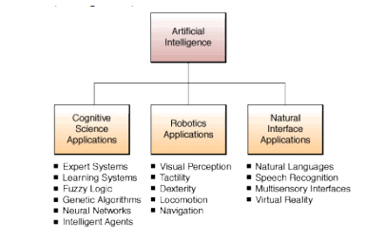
Fig 1. Overview of Artificial Intelligence
Strong AI: The principle behind Strong AI is that the machines could be made to think or in other words could represent human minds in the future. Thus Strong AI claims that in near future we will be surrounded by such kinds of machine which can completely works like human being and machine could have human level intelligence. If that is the case, those machines will have the ability to reason, think and do all functions that a human is capable of doing. Current research is nowhere near creating strong AI, and a lively debate is ongoing as to whether this is even possible .
Weak AI: The principle behind Weak AI is simply the fact that machines can be made to act as if they are intelligent. Weak AI simply states that thinking like features can be easily added to computer to make them more useful tools and this already started to happen. For example, when a human player plays chess against a computer, the human player may feel as if the computer is actually making impressive moves. But the chess application is not thinking and planning at all. All the moves it makes are previously fed in to the computer by a human and that is how it is ensured that the software will make the right moves at the right times. More examples of Weak AI are witness expert systems, drive by wires cars and speech recognisation systems Artificial Intelligence (abbreviated as AI) is the capability of a device to perform activities, which would otherwise only be expected of the human brain. These activities include the capacity for knowledge and the ability to acquire it. It also comprises of the ability to judge, understand relationships and last but not least produce original thoughts.
Intelligence = perceive + Analyse + React
Also, there is a huge different between short term memory and RAM. Short-term memory holds pointers to the long-term memory where all the information is actually stored while RAM stores data that is isomorphic to data being held on a hard disk. Also, RAM has a memory limit while there seems to be no capacity limit when it comes to short-term memory. Applications of Artificial Intelligence & Associated Technologies Jatin Borana Btech IV year, Department of Electrical Engineering, Jodhpur National University jatinborana26@gmail.com A Proceeding of International Conference on Emerging Technologies in Engineering, Biomedical, Management and Science [ETEBMS-2016], 5-6 March 2016 65 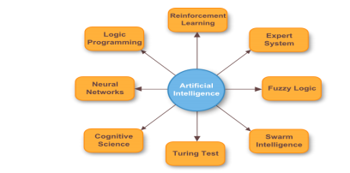
Fig 2. Areas of Artificial Intelligence
Turing Test: The Turing test is a test of a machine's ability to exhibit intelligent behavior. The test was introduced by Alan Turing in his 1950 paper Computing Machinery and Intelligence. The original question behind this test was“Can machines think?“.The test proceeds as follows a human judge engages in a natural language conversation with one human and one machine, each of which tries to appear human. All participants are placed in isolated locations. If the judge cannot reliably tell the machine from the human, the machine is said to have passed the test. In order to test the machine's intelligence rather than its ability to render words into audio, the conversation is limited to a text-only channel such as a computer keyboard and screen.” Sufficiently many interrogators are unable to distinguish the computer from the human being then it is to be concluded that the computer thinks.
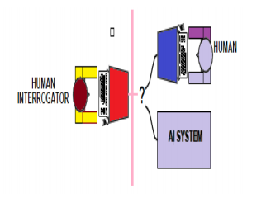
Fig 3:Turing test for checking machine intelligence
Roots of AI:Artificial Intelligence has identifiable roots in a number of older disciplines, particularly Philosophy, Logic/Mathematics, Computation, Psychology/CognitiveScience,Biology/Neuro science. There is inevitably much overlap Example, between philosophy and logic, or between mathematics and computation. By looking at each of these in turn, we can gain a better understanding of their role in AI, and how these underlying disciplines have developed to play that role.
II. ADVANTAGES AND DISADVANTAGES 1.One of the major advantages of artificial intelligence is that its decisions are based on facts rather than emotions. Even after our utmost efforts, it is a wellknown fact that human decisions are always affected in a negative way by our emotions
2.Unlike humans, machines with artificial intelligence do not need any sleep, thus overcoming the inherent disadvantage of tiredness in humans
3.Easier spreading of knowledge. Once an artificial mind is trained for something, it can be very easily copied to the others reducing the time wasted in otherwise passing on knowledge to other humans through training .
4.Lack of creativity in responses
5.Inability to explain the logic and reasoning behind a certain decision Current development is at a stage where the AI cannot know when there is no solution to a particular problem
6.Any malfunctioning can lead to the AI producing wrong solutions and since it cannot explain the reasoning behind its answer, blind reliance on AI can lead to problems
All this being said, one of the most concerning problem with the development of AI is that it will soon start substituting humans in every field thus causing a high rate of unemployment, which would lead to depression, crime and poverty. Also, there are some fields that require the human touch and there is a growing sense of belief that machines will quite possibly never be able to replace humans. The caring behavior of nurses in hospitals is one example of a job that humans feel machines will never be able to do justice to.
III. APPLICATIONS
Artificial Intelligence in the form of neural networks and expert systems has applications in almost all human activities. The combination of high precision and low computation time makes AI a cutting edge technology. Robot ES‟ s are already taking over workshop level jobs in large industries, thus side lining humans into a more supervisory role. Stock brokerage firms are now using Artificial Intelligence to analyze data, make analysis and buy or sell stocks without the interference of any human beings. Some of the applications of Artificial Intelligence are as follows,
A. Gaming Industry: One of the most commonly known applications of AI in the gaming industry is its use in chess. Even though these machines are not as intelligent as humans, they use brute force algorithms and scan 100‟ s of positions every second so as to determine the next move. As stated earlier, AI is also being used in Microsoft Xbox 360‟ s Kinect for body motion detection. But it is still in its infancy and requires a lot more advancement for it to be used in day-to-day applications.
B. Heavy industries: Artificial Intelligence robots have become very common in heavy industries and are employed in jobs that are otherwise considered dangerous for humans. These robots also increase the efficiency, as they do not need any break while working thus overcoming the inherent disadvantage of tiredness in humans.
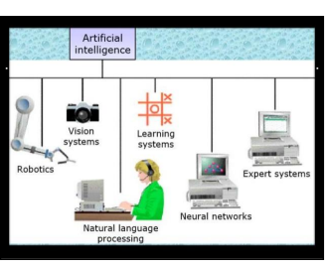
Fig 4: AI Application
C. Weather Forecasting: Neural networks are nowadays being used for predicting weather conditions. Past data is provided to the neural network, which then analyses the data for patterns and predicts the future weather conditions.
D. Expert Systems Expert: Systems are machines that are trained to have total expertise in specific areas of interest. They are developed to solve the problems in niche areas. These systems use statistical analysis and data mining to solve these problems by deducing the solutions through a logical flow of yes-no Knowledge questions.
An expert system is made up of 3 parts knowledege base- It stores all the information, rules, data and relationships that are needed by the expert system to have total expertise in its area of interest
Inference engine- It seeks information from the knowledge base on being presented with a query, analyses it and responds with a solution or recommendation in the way a human expert would Rule- It is a conditional statement that links the given ¬ conditions to the final solution
E. Data Mining or Knowledge Extraction: Data mining is a fast-growing area. Data mining is a part of a process called KDD knowledge discovery in databases. This process consists basically of steps that are performed before carrying out data mining such as data selection, data cleaning, pre-processing of data, and data transformation. "Data Mining is the use of computer algorithms to discover hidden patterns and unsuspected relationships among elements in a large data set. AI is a broader area than machine learning. AI systems are knowledge processing Proceeding of International Conference on Emerging Technologies in Engineering, Biomedical, Management and Science [ETEBMS-2016], 5-6 March 2016 67 systems. Knowledge representation, knowledge acquisition, and inference including search and control, are three fundamental techniques in AI
F. Knowledge representation: Data mining seeks to discover interesting patterns from large volumes of Data. These patterns can take various forms, such as association rules, classification rules, and decision trees, and therefore, knowledge representation becomes an issue of interest in data mining.
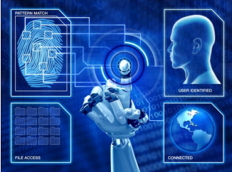
Fig 5:Pattern Matching AI Applications
IV. FUTURE ASPECTS:
The use of artificial intelligence will lead to production of machines and computers, which are much more advanced than what we have today. Speech recognition systems will reach much higher levels of performance and will be able to communicate with humans, using both text and voice, in unstructured English. There will be a great future some day for expert system applications in all aspects of health care, in both clinical and administrative areas, in improving patient care and in allocation of financial, social, and other resources. But when it comes to the question of Artificial Intelligence creating machines, which are more intelligent than human beings, no one seems to have the answer. Also, even if it is possible, the amount of time it will take cannot be predicted. It is also expected to have human brain features like learning from experience, cognition and perception. Whether human consciousness will be incorporated in these machines is still not known. Robots in the future will be able to do everybody’s work and will be faster and more efficient as compared to human beings in doing it. If one is ill, they can hire a robot nurse that will provide them with medicines at proper intervals. Thus it can be safely said that Artificial Intelligence is still in its embryonic stage and its future depends only and only upon the scientists solving the mystery of the human brain. Till that is done, no one can make a conclusion of whether our future will be affected positively or negatively by Artificial Intelligence. VI.
V.CONCLUSION
The computing world has a lot to gain or benefits from various AI approaches. Their ability to learn by example makes them very flexible and powerful. Furthermore there is no need to devise an algorithm in order to perform a specific task i.e. there is no need to understand the internal mechanisms of that task. They are also very well suited for real time systems because of their fast response and computational times which are due to their parallel architecture. The goal of artificial intelligence is to create computers whose intelligence equals or surpasses humans. Achieving this goal is the famous “AI problem from last decade researchers are trying to close the gap between human intelligence and artificial intelligence.
REFERENCES
[1] George F Ludger “Artificial Intelligence - Structures and strategies for complex problem solving” 5th Edition, Pearson, 2009.
[2] Girish Kumar jha, "Artificial Neural Networks and its applications" international journal of computer science and issues 2005.
[3] Nils J Nilsson American Association for Artificial Intelligence" AI magazine 2005.
[4] Xindong Wu, Senior Member, IEEE "Data Mining: An AI Perspective" vol.4 no 2 (2004)
[5] Satvika Khanna et al. “Expert Systems Advances in Education” NCCI 2010 –National Conference on Computational Instrumentation CSIO Chandigarh, INDIA, 19-20 March 2010
[6] Kaijun Xu.” Dynamic neuro-fuzzy control design for civil aviation aircraft in intelligent landing system. Dept. of Air Navig. Civil Aviation Flight Univ. of China 2011.
[7] Eike.F Anderson.,”Playing smart artificial intelligence in computer games” The National Centre for Computer Animation (NCCA) Bournemouth University UK.
[8] K.R. Chaudhary “Goals, Roots and Sub-fields of Artificial Intelligence. MBM Engineering College, Jodhpur, India

