BLOOD BUD
A Chandrakeerthi, A Dinesh
Department of Computer Science & Engineering
Sree Visvesvaraya Institute of Technology and Science
Chowderpally,Mahaboobnagar
chandrakeerthiagaram@gmail.com,kumardinesh73596@gmail.com

ABSTRACT:
Online Blood Bud project aims at maintaining all the information pertaining to blood Donors, different blood groups available in each blood bank and help them manage in the better way. The blood donors can register to this system by entering their profile information.

1.EXISTING SYSTEM:
A number of online blood bank databases are available, however none of them offer the capability for a direct contact between the donor and recipient. This is a major drawback particularly in cases where there is an urgent need of blood.

1.1.LIMITATIONS:
1.It is time consuming
2.It consumes lot of man power for better results
3.It lacks of data security
4.Percentage of accuracy is less
5.It becomes difficult to look for exact match of blood group of donor or acceptor.
2.PROPOSED SYSTEM:
The proposed system, online Blood Bud Site overcomes the drawback of the present system. The Blood Bud helps the people who are in need of a blood by giving them overall details regarding the donors with the same blood group and within their city.

2.1.ADVANTAGES:
It is very flexible and user friendly
The persons time and work is reduced
It provides reliable security measures
Easy addition and updating of donors details through online.
This supports multiple users
This project has SMS feature. The bulk SMS alert automatically goes to all blood donors.
It automates the complete operations of the blood bank thus, improves the quality and management of blood bank.
3.SOFTWARE REQUIREMENTS:
- Front End: JSP, Java script
- Database: MySql/Oracle
- IDE: Netbeans
4.HARDWARE REQUIREMENTS:
- RAM: 1 GB
- Operating System: Windows Family
- Hard Disk: 100 GB
- Processor: 1.5 GHZ

5.UML Diagrams
The Unified Modeling Language (UML) is a general-purpose modeling language in the field of software engineering, which is designed to provide a standard way to visualize the design of a system. Design is concerned with identifying software components specifying relationships among components. Specifying software structure and providing Blue print for the documents phase.
The Unified Modeling Language is a standard language for Specifying, Visualizing, Constructing, and documenting the software system and its components. It is a graphical language, which provides a vocabulary and set of semantics and rules. The UML focuses on the conceptual and physical representation of the system. It captures the decisions and understandings about systems that must be constructed. It is used to understand, design, configure, maintain and control information about the system.
Through UML, we can see or visualize an existing system and ultimately we can visualize how the system is going to be after implementation. It helps to visualize how the components of the system communicate and interact with each other. Specifying means building models that are precise, unambiguous and complete UML addresses the specification of all the important Analysis Design, Implementation decisions that must be made in developing and deploying a Software system.
There are two broad categories of diagrams and then are again divided into sub categories.
- Structural Diagrams
- Behavioral Diagrams
5.1Structural Diagrams
The structural diagrams represent the static aspect of the system. These static aspects represent those parts of a diagram which forms the main structure and therefore stable. These static parts are represents by classes, interfaces, objects, components, and nodes. The four structural diagrams are as follows:
- Class diagram
- Object diagram
- Component diagram
- Deployment diagram
5.2Behavioral diagrams
Behavioral diagrams basically capture the dynamic aspect of a system. Dynamic aspect can be further described as the changing moving parts of a system. UML has the following five types of behavioral diagrams, they are:
- Use case diagram
- Interaction diagram
- State chart diagram
- Activity diagram
5.5.1 Class Diagram
In software engineering, a class diagram in the Unified Modeling Language (UML) is a type of static structure diagram that describes the structure of a system by showing the system's classes, their attributes, operations (or methods), and the relationships among objects.
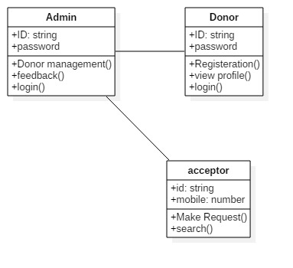
Fig: Class Diagram for Admin , Donar & Acceptor

5.5.2 Use Case Diagram
A use case diagram at its simplest is a representation of a user's interaction with the system and depicting the specifications of a use case. A use case diagram can portray the different types of users of a system and the case and will often be accompanied by so other types of diagrams as well. In software and systems engineering, a use case is a list of steps.
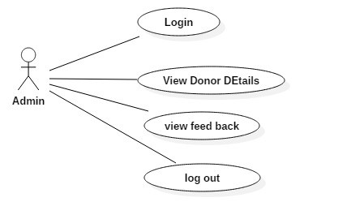
Fig. Use case Diagram for Admin
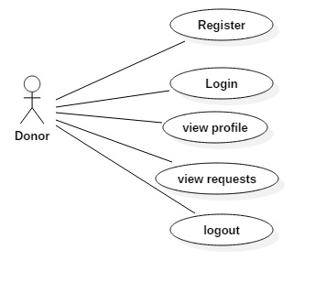
Fig. Use case Diagram for Donor
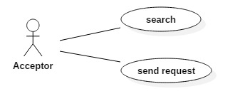
Fig. Use case Diagram for Acceptor

5.5.3 Sequence Diagram
A Sequence diagram is an interaction diagram that shows how processes operate with one another and in what order. It is a construct of a Message Sequence Chart. A sequence diagram shows object interactions arranged in time sequence
. 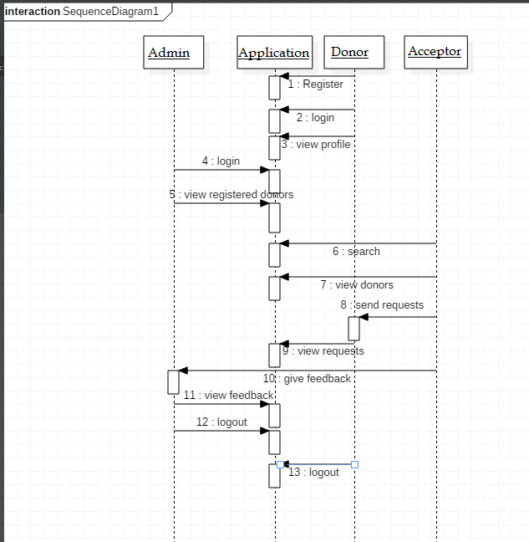
Fig Sequence Diagram for Admin, Donor and Acceptor
5.5.4 Collaboration Diagram
A collaboration diagram describes interactions among objects in terms of sequenced messages. Collaboration diagrams represent a combination of information taken from class, sequence, and use case diagrams describing both the static structure and dynamic behavior of a system.
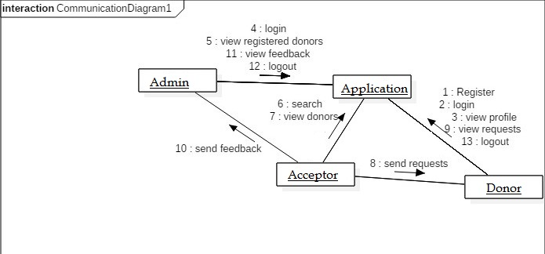

Fig. Collaboration Diagram for Admin, Donor and Acceptor
5.5.5 Activity Diagram
Activity diagrams are graphical representations of workflows of stepwise activities and actions with support for choice, iteration and concurrency. In the Unified Modeling Language, activity diagrams are intended to model both computational and organizational processes. Activity diagrams show the overall flow of control. Activity diagrams may be regarded as a form of flowchart.
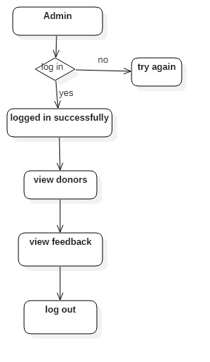
Fig :Activity Diagram for Admin

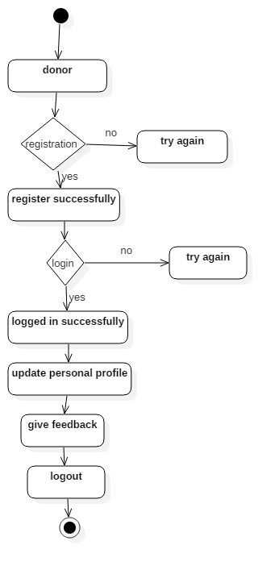

Fig :Activity Diagram for Donors

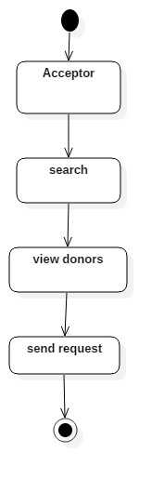
Fig :Activity Diagram for Acceptors

