The role Of Big Data in Banking Industry

Introduction:

The banking industry has evolved by leaps and bounds over the past decade, when it comes to operations and service delivery. Surprisingly though, most banks have failed to utilize the information within their own databases. However, that’s all about to change as the banking sector gears up to process immense volumes of data created and collected. Some industry experts expect a sevenfold increase in the volume of data, before 2020. Big Data is huge step towards the development of banking industries, and will propel it into the 21st century. Let’s take a look at big data’s advantages for the banking industry, and how it will make things easier.

Why Is Big Data Different?
In the old days… you know… a few years ago, we would utilize systems to extract, transform and load data (ETL) into giant data warehouses that had business intelligence solutions built over them for reporting. Periodically, all the systems would backup and combine the data into a database where reports could be run and everyone could get insight into what was going on.
The problem was that the database technology simply couldn’t handle multiple, continuous

streams of data. It couldn’t handle the volume of data. It couldn’t modify the incoming data in real-time. And reporting tools were lacking that
couldn’t handle anything but a relational query on the back-end. Big Data solutions offer cloud hosting, highly indexed and optimized data
structures, automatic archival and extraction capabilities, and reporting interfaces have been designed to provide more accurate analyses that enable businesses to make better decisions.
Better business decisions mean that companies can reduce the risk of their decisions, and make better decisions that reduce costs and increase marketing and sales effectiveness.
Comprehensive Progress Evaluation
The internet and data analytics have already made it so much easier to monitor and evaluate the progress banks, which have been entrusted with tons of their clients’ personal information. But with big data, banks can now use this information to constantly monitor their client’s transaction behaviours in real time, allowing them to provide the kind of resources that their clients need. This real-time evaluation will boost overall profitability.
As the volume of banking customers’ increases, it is almost bound to affect the level of service offered. But it is important for the banks to be on top of everything as they are responsible for the security of their clients’ funds, as well as their personal data. Small scale databases simply cannot keep with the increasing volume of information. So, if the banking sector fails to successfully implement Big Data, their databases are almost certain to fail.
Switching to Big Data will allow them to process this information faster, avoiding any potentially embarrassing situations.
Changes in Service Delivery
Big Data might comprise of an enormous system, but its job is to simplify tasks. Whenever a name or account number is entered into system, it sifts through all the data and provides only the required information. This will allow banks to streamline work processes, and saves both time and costs. Big Data will also allow organizations to identify and rectify problems, before they affect their clients.Sometimes the clients can also be the source of an issue.
For example, investors might make a decision, but then change their mind at a later point of time. Big Data will help the banking industry to change their method of service delivery in a way where such erroneous clients won’t be able to walk out on their commitments. It will allow the banking industry to track customers’ credit card and loan limits, ensuring that they don’t over spend.
Advantages of Big Data .
The cloud presents a huge opportunity for the evolution of the banking sector, which has remained largely unchanged over the years. And although there are concerns related to data security, Big Data can offer a number of advantages for, both banks and their customers.
1. Fraud Detection & Prevention
One of the biggest problems faced by the banking sector is fraud. And Big Data will allow banks to make sure that no unauthorized transactions will be made, providing a level of safety and security that will raise the security standard of the entire industry.
2. Enhanced Compliance Reporting
Banks now have access millions or even billions of customers’ needs, and they can now use Big Data to cater to them in a more meaningful way. Cloud based analytics packages can sync in real time with your big data systems, creating actionable insight dynamically. Big Data will expand the banking industry in a way that will allow them to earn mores revenue through cost reduction. And by cutting down on unnecessary costs, the banking industry can provide customers with exactly what they’re looking for, instead of irrelevant information.
Customer Segmentation
Big Data will give banks deep insights into customer spending habits and patterns, simplifying the task of ascertaining their needs and wants. By being able to track and trace each and every customer transaction, banks will be able to categorize their clients based on various parameters, including commonly accessed services, preferred credit card expenditures, or even net worth. The benefit of customer segmentation is that it allows banks to better target their clients with relatable marketing campaigns that are tailored to cater to their requirements. Herman Shooster, Founder of Globalresponse.com, was a big advocate of Big Data for Customer segmentation .
Personalized Product Offerings:
Customer segmentation can further be used to create and deliver new schemes and plans, aimed directly at the specific requirements of their customers. By analysing past and present expenses and transactions, a bank can get a clear understanding of how to get the highest response rate from their clients. Creation of personalized product offerings will cater to an untapped niche of personalized services that gives banks the ability to create more meaningful client relationships.Risk Management
The early detection of fraud is a large part of risk management, and Big Data can do as much for risk management, as it does for fraud identification. Big Data locates and presents big data on a single large scale that makes it easier to reduce the number of risks to a manageable number. Big Data plays a pivotal role in integrating the banks requirements into a centralized, functional platform. This reduces the banks chances of losing data, or ignoring fraud.
By keeping up with Big Data and other newer global trends, the banking industry will be able to get a better understanding of client requirements, so that they can provide such services in a timely manner. The task of implementing Big Data on a large scale is just taking shape, with many IT departments concerned about the transition to high-tech IT infrastructure. But when it comes to Big Data adoption in the banking industry, the sooner the better!
Benefits of Big Data:
Informatica walks through the risks and opportunities associated with leveraging big data in corporations.
- Big Data is Timely – 60% of each workday, knowledge workers spend attempting to find and manage data.
- Big Data is Accessible – Half of senior executives report that accessing the right data is difficult.
- Big Data is Holistic – Information is currently kept in silos within the organization. Marketing data, for example, might be found in web analytics, mobile analytics, social analytics, CRMs, A/B Testing tools, email marketing systems, and more… each with focus on its silo.
- Big Data is Trustworthy – 29% of companies measure the monetary cost of poor data quality. Things as simple as monitoring multiple systems for customer contact information updates can save millions of dollars.
- Big Data is Relevant – 43% of companies are dissatisfied with their tools ability to filter out irrelevant data. Something as simple as filtering customers from your web analyticscan provide a ton of insight into your acquisition efforts.
- Big Data is Secure – The average data security breach costs $214 per customer. The secure infrastructures being built by big data hosting and technology partners can save the average company 1.6% of annual revenues.
- Big Data is Authoritive – 80% of organizations struggle with multiple versions of the truth depending on the source of their data. By combining multiple, vetted sources, more companies can produce highly accurate intelligence sources.
- Big Data is Actionable – Outdated or bad data results in 46% of companies making bad decisions that can cost billions.

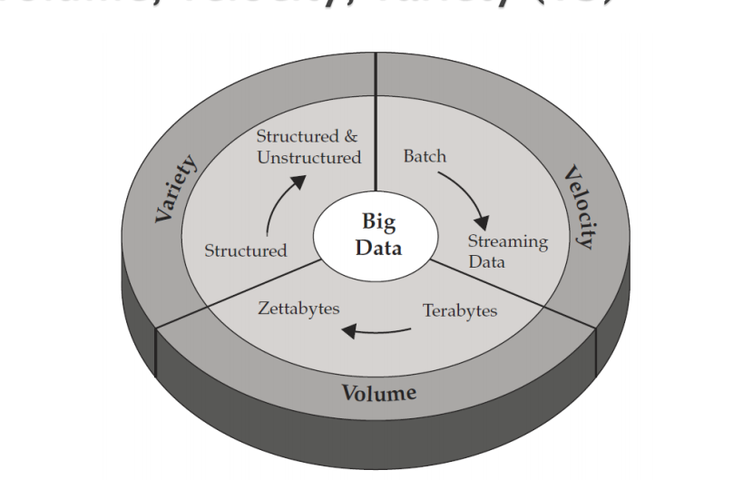
Charcterization of Big Data:
Volume ,velocity and vector
Tools used in Big Data:
NoSQL ◦ DatabasesMongoDB, CouchDB, Cassandra, Redis, BigTable, Hbase, Hypertable, Voldemort, Riak, ZooKeeper
 MapReduce ◦ Hadoop, Hive, Pig, Cascading, Cascalog, mrjob, Caffeine, S4, MapR, Acunu, Flume, Kafka, Azkaban, Oozie, Greenplum
 Storage ◦ S3, Hadoop Distributed File System  Servers ◦ EC2, Google App Engine, Elastic, Beanstalk, Heroku
 Processing ◦ R, Yahoo! Pipes, Mechanical Turk, Solr/Lucene, ElasticSearch, Datameer, BigSheets, Tinkerpop

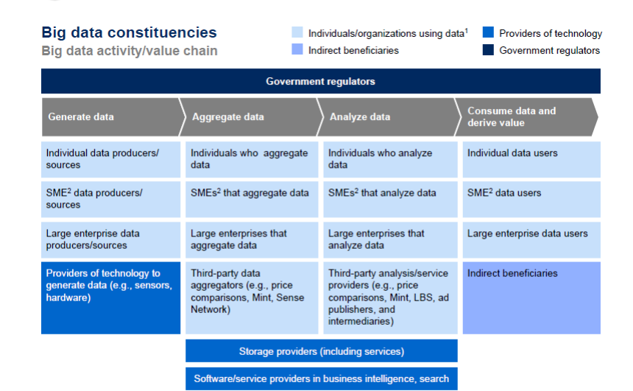
Big Data Value Chain:
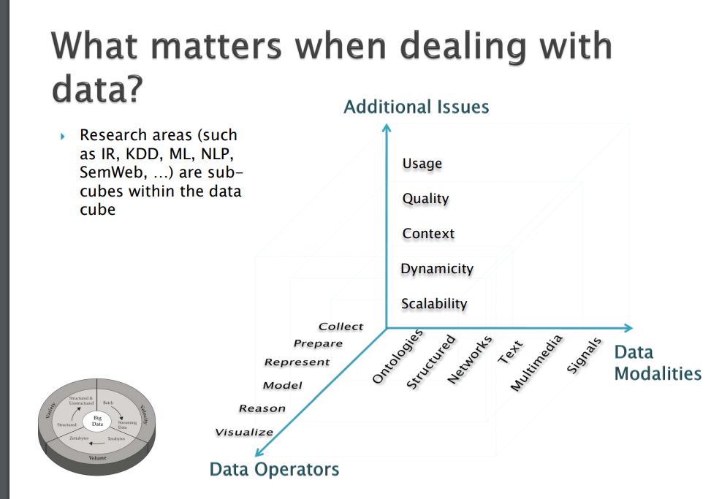

Dealing with the big Datrle Challanges of big data in banking :
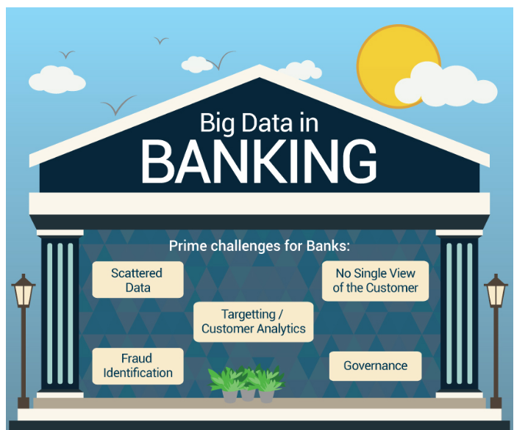

The Banking industry generates a huge volume of data on a day to day basis. To differentiate itself from the competition, banks are increasingly adopting big data analytics as part of their core strategy. Analytics will be the critical game changer for the banks. In this infographic we will explore the scale at which banks have adopted analytics in their business.

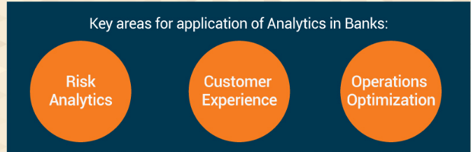
Key features in banking sector:

Advantages of big data in banking:

1. Efficient risk management that helps detect errors and frauds in real-time
Business Intelligence (BI) tools that function on top of big data to provide analytics can identify the risks in sanctioning loans to potential customers. Banks can analyze the market trendsaccording to regional data available and decide on lowering or increasing interest rates in that segment.
Errors while copying data from forms manually are reduced to minimum. Other data entry errors are also rectified before they can affect the working of the bank, as big data analytics can point out anomalies in customer data.Bank frauds often go unnoticed till they disrupt the functioning of the banking services. With big data, banks can identify fraudulent transactions or entries at the onset as they vary from the acceptable standards set in the analytics dashboards.
2. Analyze consumer behavior and provide personalized banking solutions
Often, banks miss out on customers, as they do not connect emotionally with them. Sales representatives and relationship managers can leverage the inputs from the big data analytics that help identify investment patterns of the customers, their financial and personal backgrounds, and their motivations to invest, so that they can provide personalized investment solutions that are a combination of accounts, insurances, loans. Essentially, complete systematic investment plans that will ensure that the customers trust the bank with their finances.
3. Regulatory compliances are easier to file using big data
68% of bank employees say that their biggest concern in banking services is ensuring that they meet all the regulatory compliances set by the Government.role of Abig data in the banking industry

4. Performance analytics using big data help in budgeting and innovation
Branch goals are based on employee performance, and the targeted revenue for the year. Big data analytics can generate suggestions based on the figures available from the current sales of employees, and help bank allocate budget for each branch.
Even the services themselves can be analyzed for performance, to know what works and what needs to be changed. This fosters innovation amongst the marketing teams.
5. Maximize lead generation
Big data not only helps in existing customer retention but also in converting new customers through the personalized solutions that are discussed above in point .

Challenges:

1. Difficult to harness siloed data
Banking services data is highly diverse, and stored in different departments. It is difficult to profile a customer based on his/her investment behavior as his accounts, loans, insurances, etc. may be spread over various branches and departments of the bank. Big data needs to collate all such data first, in order to provide comprehensive intelligence.
2. Legacy infrastructure needs to be upgraded before integrating big data capabilities
Most banking solutions are not equipped to handle constant influx of data, which is a pre-requisite for big data, even if they have moved to cloud solutions. Integrating big data requires a complete revamp of most of the existing bank solutions in partnership with a big data consulting company.
This is not easy to implement, as the system needs to be constantly up even when the changes are being deployed.
3. Dedicated resources and tie ups with big data consulting company mandatory for correct implementation
As mentioned above, it is highly unlikely that banks would have in-house data experts in big data, and hence, partnership with firms specializing in designing, developing and deploying big data solutions is a must.

4. Big data is not yet viewed as a strategic asset
Non-technical managers and top-level executives often bypass the need of big data by relying more on human decisions rather than the automated marketing solutions offered by the analytics dashboard. This results either results in the bank not opting for big data or sidelining the actionable inputs from the big data implementations.

5. Customer concerns about privacy
Although the data logged by big data systems is anonymous at the high level, if the bank wishes, they can track behavior patterns of each individual customer. It is advantageous in detecting illegal activities, but is a serious security threat to the customer if it falls into wrong hands. Several concerns have already been raised with the Government about monitoring the use of big data.
Conclusion:

The Banking industry generates a huge volume of data on a day to day basis. To differentiate itself from the competition, banks are increasingly adopting big data analytics as part of their core strategy. Analytics will be the critical game changer for the banks. In this infographic we will explore the scale at which banks have adopted analytics in their business.

