**Internet of Things - Applications and Challenges**

G.Manasa,K.Sindhu

Department of Computer Science and Engineering

Sree Visvesvaraya Institute of Technology and Science

Chowderpally,Mahaboobnagar

manasa.giddalapati02@gmail.com,sindhu03krs@gmail.com

## **ABSTRACT**

Nowadays Internet of Things (IoT) gained a great attention from researchers, since it becomes an important technology that promises a smart human being life, by allowing a communications between objects, machines and every things together with peoples. IoT represents a system which consists a things in the real world, and sensors attached to or combined to these things, connected to the Internet via wired and wireless network structure. The IoT sensors can use various types of connections such as RFID, Wi-Fi, Bluetooth, and ZigBee, in addition to allowing wide area connectivity using many technologies such as GSM, GPRS, 3G, and LTE. IoT-enabled things will share information about the condition of things and the surrounding environment with people, software systems and other machines. by the technology of the IoT, the world will becomes smart in every aspects, since the IoT will provides a means of smart cities, smart healthcare, smart homes and building, in addition to many important applications such as smart energy, grid, transportation, waste management and monitoring . In this paper we review a concept of many IoT applications and future possibilities for new related technologies in addition to the challenges that facing the implementation of the IoT.

***Keywords*:** IoT Applications, Future Technologies, Smart Cities, Smart Environment, Smart Energy and Grid, Smart Manufacturing, Smart Healthcare

# 1. INTRODUCTION

The Internet of Things (IoT), sometimes referred to as the Internet of Objects, will change everything including ourselves. The Internet has an impact on education, communication, business, science, government, and humanity [1]. Clearly, the Internet is one of the most important and powerful creations in all of human history and now with the concept of the internet of things, internet becomes more favorable to have a smart life in every aspects [2].

Internet of Things is a new technology of the Internet accessing. By the Internet of Things, objects recognize themselves and obtain intelligence behavior by making or enabling related decisions thinks to the fact that they can communicate information about themselves [3]. These objects can access information that has been aggregated by other things, or they can added to other services [3]. Figure 1 reviews that with the internet of things, anything’s will able to communicate to the internet at any time from any place to provide any services by any network to anyone. this concept will create a new types of applications can involve such as smart vehicle and the smart home, to provide many services such as notifications, security, energy saving, automation, communication, computers and entertainment [4,5].

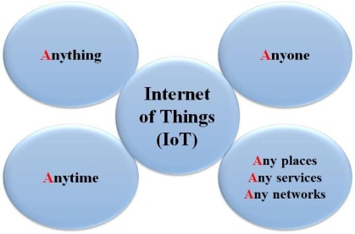

## **Figure 1.** Internet of things Concept

By developing the IoT technology, testing and deploying products it will be much close to implementing smart environments by 2020 [6]. In the near future, storage and communication services will be highly pervasive and distributed: people, machines, smart objects, surrounding space and platforms connected with wireless/wired sensors, M2M devices, RFID tags will create a highly decentralized resources interconnected by a dynamic network of networks [7].

In the IoT, the communication language will be based on interoperable protocols, operating in heterogeneous environments and platforms [8]. IoT in this context is a generic term and all objects can play an active role to their connection to the Internet by creating smart environments, where the role of the Internet has changed [9].

The aim of this paper is presents the internet of things Applications, Related Future Technologies, and challenges .The remainder of this paper is structured as follows: section 2 provides a concept of internet of things Standardizations. In section 3 the application of internet of thing will be discussed. Section 4 will provide Internet of Things and Related Future Technologies and the challenges that facing the IoT will be reviewed in section 5. Finally the chapter will ended by a conclusion of the overall sections.

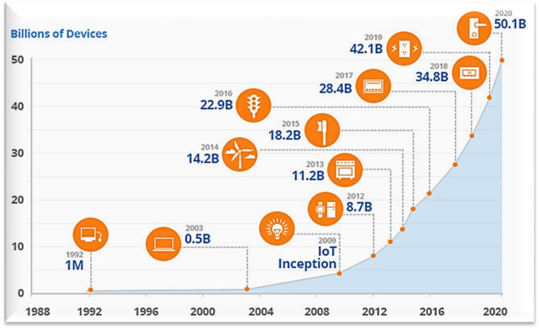

## **Figure 2.** Internet of Things Growth

2. INTERNET OF THINGS APPLICATIONS

Internet of things promises many applications in human life, making life easier, safe and smart. There are many applications such as smart cities, homes, transportation, energy and smart environment.

# A. Smart Cities

Many major cities were supported by smart projects, like Seoul, New York, Tokyo, Shanghai, Singapore, Amsterdam, and Dubai. Smart cities may still be viewed as a cities of the future and smart life, and by the innovation rate of creating smart cities today’s, it will became very feasible to enter the IoT technology in cities development [30]. Smart cities demand require careful planning in every stage, with support of agreement from governments, citizens to implement the internet of things technology in every aspects. By the IoT, cities can be improved in many levels, by improving infrastructure, enhancing public transportation reducing traffic congestion, and keeping citizens safe, healthy and more engaged in the community as shown in Figure 3 [31]. By connection all systems in the cities like transportation system, healthcare system, weather monitoring systems and etc., in addition to support people by the internet in every place to accessing the database of airports, railways, transportation tracking operating under specified protocols, cities will become smarter by means of the internet of things [32,33].

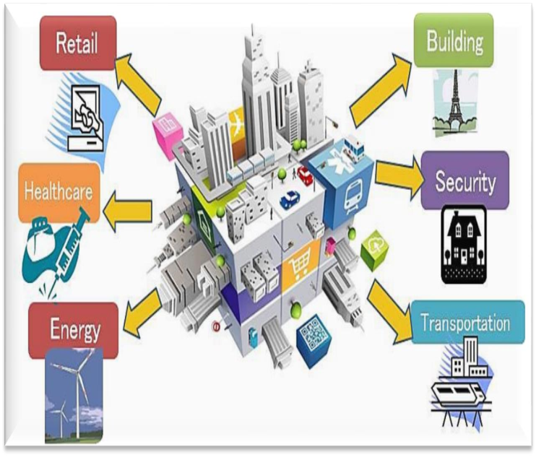

**Figure 3.** Smart Cities Aspects

# B. Smart Home and Buildings

Wi-Fi’s technologies in home automation has been used primarily due to the networked nature of deployed electronics where electronic devices such as TVs, mobile devices, etc are usually supported by Wi-Fi [34]. Wi-Fi have started becoming part of the home IP network and due the increasing rate of adoption of mobile computing devices like smart phones, tablets, etc. For example a networking to provide online streaming services or network at homes, may provide a mean to control of the device functionality over the network [35]. At the same time mobile devices ensure that consumers have access to a portable ‘controller’ for the electronics connected to the network. Both types of devices can be used as gateways for IoT applications [36]. Many companies are considering developing platforms that integrate the building automation with entertainment, healthcare monitoring, energy monitoring and wireless sensor monitoring in the home and building environments [37]. By the concept of the internet of things, homes and buildings may operate many devices and objects smartly, of the most interesting application of IoT in smart homes and buildings are smart lighting, smart environmental and media, air control and central heating, energy management and security as shown in Figure 4 below.

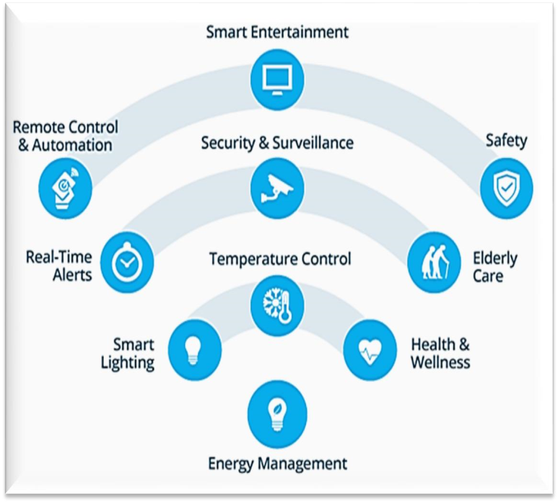

## **Figure 4.** Smart Home & building applications

Wireless sensor networks (WSNs) with integration to the internet of things technology will provides an intelligent energy management in buildings, in addition to the obvious economic and environmental gains. Internet together with energy management systems also offers an opportunity to access a buildings’ energy information and control systems from a laptop or a smartphone placed anywhere in the world [38]. The future Internet of Things, will provide an intelligent building management systems which can be considered as a part of a much larger information system used by facilities managers in buildings to manage energy use and energy procurement and to maintain buildings systems [39,40].

### C. Smart Energy and the Smart Grid

A smart grid is related to the information and control and developed to have a smart energy management [41]. A smart grid that integrate the information and communications technologies (ICTs) to the electricity network will enable a real time, two way communication between suppliers and consumers, creating more dynamic interaction on energy flow, which will help deliver electricity more efficiently and sustainably [42]. The Key elements of information and communications technologies will include sensing and monitoring technologies for power flows; digital communications infrastructure to transmit data across the grid; smart meters with in home display to inform energy usage; coordination, control and automation systems to aggregate and process various data,and to create a highly interactive responsive electricity [43]. Many applications can be handling due to the internet of things for smart grids, such as industrial, solar power, nuclear power,vehicles,hospitals and cities power control.Fig 5 shows the most important applications may be enabled by the internet of things in smart grid aspect.

.

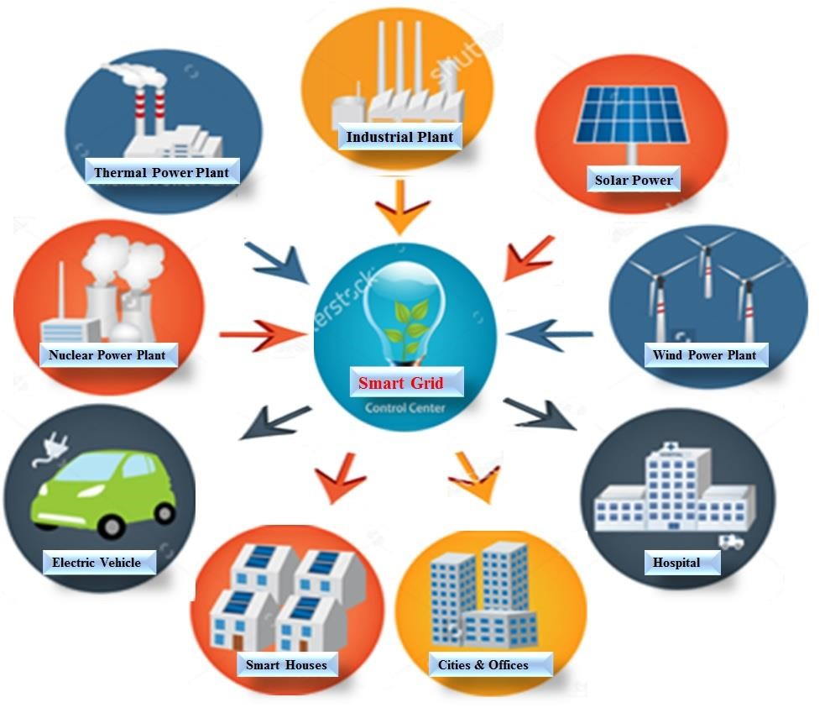

## **Figure 5.** Smart grid applications

Today’s grid is very reliable and can deal with normal electricity fluctuations and it will take a step further towards using a low carbon energy system, by allowing integration between the renewable energy and green technologies, and offering many benefits to customer in cost savings through efficient energy use at home [44].

### D. Smart Health

A close attention that required to hospitalized patients whose physiological status should be monitored continuously can be constantly done by using IoT monitoring technologies. For smart health sensors are used to collect comprehensive physiological information and uses gateways and the cloud to analyze and store the information and then send the analyzed data wirelessly to caregivers for further analysis and review as shown in Figure 6 below [45]. It replaces the process of having a health professional come by at regular intervals to check the patient’s vital signs, instead providing a continuous automated flow of information. In this way, it simultaneously improves the quality of care through constant attention and lowers the cost of care by reduces the cost of traditional ways of care in addition to data collection and analysis [46].

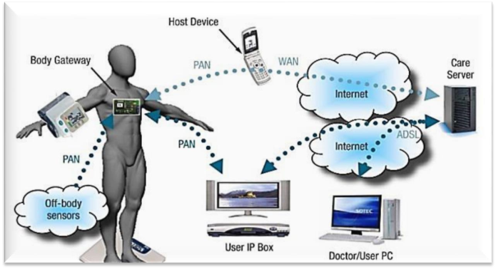

## 

## **Figure 6.** Smart healthcare concept

Many peoples around the worlds are suffering from the bad health because they don’t have ready access to effective health monitoring and may be a suspected to be as critical situation patients. But with small, powerful wireless solutions connected through the IoT are now making possible for monitoring to come to these patients. These solutions can be used to securely capture patient health data from a variety of sensors, apply complex algorithms to analyze the data and then share it through wireless connectivity with medical professionals who can make appropriate health recommendations [47].

# E. Smart Transportation and Mobility

The development in transportation is one of the factors to indicate the wellbeing of the country. A road condition monitoring and alert application is one of the most important of IoT transformation application [48]. The main idea of the concept of smart transportation and mobility is to apply the principles of crowd sourcing and participatory sensing. The process began with user identified the route wishes and marked some points as pothole in the smart phone's application [49]. The smart transportation is deal with three main conceptions as shown in Figure 7, they are transportation analytic, transportation control, and vehicle connectivity. The transportation analytic represents the analysis of demand prediction and anomaly detection. The routing of vehicles and speed control in addition to traffic management are all known as transportation control which they actually tightly related to the way of the vehicles connectivity (V2X communication), and overall governed by multi-technology dissemination.

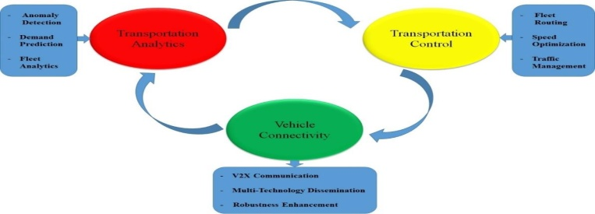

## **Figure 7.** Smart Transportation Aspects

IoT can also be used in transportation is an electric vehicles, which is an important means to reduce both the fuel cost and the impact of global warming have also gained considerable attention from drivers. Government in many countries has supported researches on systems to monitor performance of Lithium-ion (Li-on) battery for electric vehicle as explored. The system presented was designed to detect the functions of Li-on power battery by deriving the driving situation from the realistic working conditions for driver so that the driver was able to get the idea of the route status. This solution was embedded with many essential functions such as dynamic performance test of the Li-on battery, remote monitoring with on-line debugging and error correction that could significantly reduce the maintenance cost [50].

# 4. INTERNET OF THINGS CHALLENGES

The fact that Internet of things applications and scenarios outlined above are very interesting which provides technologies for smart every things. , but there are some challenges to the application of the Internet of Things concept in cost of implementation. The expectation that the technology must be available at low cost with a large number of objects. IoT are also faced with many other challenges [69,70], such as:

* **Scalability:** Internet of Things has a big concept than the conventional Internet of computers, because of things are cooperated within an open environment. Basic functionality such as communication and service discovery therefore need to function equally efficiently in both small scale and large scale environments. The IoT requires a new functions and methods in order to gain an efficient operation for scalability.
* **Self-Organizing:** Smart things should not be managed as computers that require their users to configure and adapt them to particular situations. Mobile things, which are often only sporadically used, need to establish connections spontaneously, and able to be organize and configure themselves to suit their particular environment.
* **Data volumes:** Some application scenarios of the internet of things will involve to infrequent communication, and gathering information’s form sensor networks, or form logistics and large scale networks, will collect a huge volumes of data on central network nodes or servers. The term represent this phenomena is big data which is requires many operational mechanism in addition to new technologies for storing, processing and management.
* **Data interpretation:** To support the users of smart things, there is a need to interpret the local context determined by sensors as accurately as possible. For service providers to profit from the disparate data that will be generated, needs to be able to draw some generalizable conclusions from the interpreted sensor data.
* **Interoperability:** Each type of smart objects in Internet of Things have different information, processing and communication capabilities. Different smart objects would also be subjected to different conditions such as the energy availability and the communications bandwidth requirements. To facilitate communication and cooperation of these objects, common standards are required.
* **Automatic Discovery:** In dynamic environments, suitable services for things must be automatically identified, which requires appropriate semantic means of describing their functionality.
* **Software complexity:** A more extensive software infrastructure will be needed on the network and on background servers in order to manage the smart objects and provide services to support them. that because the software systems in smart objects will have to function with minimal resources, as in conventional embedded systems.
* **Security and privacy:** In addition to the security and protection aspects of the Internet such in communications confidentiality, the authenticity and trustworthiness of communication partners, and message integrity, other requirements would also be important in an Internet of Things. There is a need to access certain services or prevent from communicating with other things in IoT and also business transactions involving smart objects would need to be protected from competitors’ prying eyes.
* **Fault tolerance:** Objects in internet of things is much more dynamic and mobile than the internet computers, and they are in changing rapidly in unexpected ways. Structuring an Internet of Things in a robust and trustworthy manner would require redundancy on several levels and an ability to automatically adapt to changed conditions.
* **Power supply:** Things typically move around and are not connected to a power supply, so their smartness needs to be powered from a self-sufficient energy source. Although passive RFID transponders do not need their own energy source, their functionality and communications range are very limited. Hopes are pinned on future low power processors and communications units for embedded systems that can function with significantly less energy. Energy saving is a factor not only in hardware and system architecture, but also in software, for example the implementation of protocol stacks, where every single transmission byte will have to justify its existence.

**Wireless communications:** From an energy point of view, established wireless technologies such as GSM, UMTS, Wi-Fi and Bluetooth are far less suitable; more recent WPAN standards such as ZigBee and others still under development may have a narrower bandwidth, but they do use significantly less power.

# 6. CONCLUSIONS

Internet of things is a new technology which provides many applications to connect the things to things and human to things through the internet. Each objects in the world can be identified, connected to each other through internet taking decisions independently. All networks and technologies of communication are used in building the concept of the internet of things such technologies are mobile computing, RFID, wireless sensors networks, and embedded systems, in addition to many algorithms and methodologies to get management processes, storing data, and security issues. IoT requires standardized approach for architectures, identification schemes, protocols and frequencies will happen parallels, each one targeted for a particular and specific use. by the internet of things many smart applications becomes real in our life , which enable us to reach and contact with every things in addition to facilities many important aspects for human life such as smart healthcare, smart homes, smart energy , smart cities and smart environments.

Internet of things may facing two major challenges in order to guarantee seamless network access; the first issue relates to the fact that today different networks coexist and the other issue is related to the big data size of the IoT. Other current issues, such as address restriction, automatic address setup, security functions such as authentication and encryption, and functions to deliver voice and video signals efficiently will probably be affected in implementing the concept of the internet of things but by ongoing in technological developments these challenges will be overcome. The internet of things promises future new technologies when related to cloud, fog and distributed computing, big data, and security issues. By integrating all these issues with the internet of things, smarter applications will be developed as soon. This paper surveyed some of the most important applications of IoT with particular focus on what is being actually done in addition to the challenges that facing the implementation the internet of things concept, and the other future technologies make the concept of IoT feasible.

# References

1. M. A. Ezechina, K. K. Okwara, C. A. U. Ugboaja. The Internet of Things (Iot): A Scalable Approach to Connecting Everything. *The International Journal of Engineering and Science* 4(1) (2015) 09-12.
2. <http://www.meraevents.com/event/iot-workshop>
3. http://www.nxp.com/assets/documents/data/en/white-papers/INTOTHNGSWP.pdf
4. Saranya C. M., Nitha K. P., Analysis of Security methods in Internet of Things. *International Journal on Recent and Innovation Trends in Computing and Communication,* Volume 3, Issue 4; April 2015.
5. Sapandeep Kaur, Ikvinderpal Singh. A Survey Report on Internet of Things Applications. *International Journal of Computer Science Trends and Technology* Volume 4, Issue 2, Mar - Apr 2016.
6. S. Misra et al., Security Challenges and Approaches in Internet of Things. Springer Briefs in Electrical and Computer Engineering, 2016.
7. Suwimon Vongsingthong and Sucha Smanchat. A Review of Data Management in Internet of Things. *KKU Res. J.* 2015
8. http://cdn2.hubspot.net/hubfs/552232/Downloads/Partner_program/Smart_Environment s_Flyer.pdf?t=1458917278396