RESULTS THROUGH E-MAIL

A Raghuvamshi, S Sathyanarayana
Department of Computer Science & Engineering
Sree Visvesvaraya Institute of Technology and Science
Chowderpally,Mahaboobnagar
raghuvamshi966@gmail.com,satyanarayana04@gmail.com

Abstract: The word entasi came from greek origin which means tension and the name of the website gives the meaning tension free. The ides of this E-RESULTS.com website entasi free came into existence due to the problem faced by the students during the time of results. Generally, all the students face the problem in checking their results as soon as they are kept into portal. Because the server gets bulk login requests and it just breaks down. The one click solution to this problem is our website entasi free which enables the students to get the results through email. Here the email id’s of the students are linked with the websites as soon as the administrator logins and submit the details the mails are sent to the respective email id’s.
1. INTRODUCTION:
In this project E-mail technology is implemented for the fast and reliable procurement of exam results. Now also even after the publication of exam result by the university/board, the candidates have to wait a long time to get their result details. This problem is tried to be solved through this system which uses E-mail to provide exam results to the registered candidates.The candidates who have registered for exam will have to provide their E-mail Id and mobile number for contact. After the exam result has been published from the university these candidates can check the results and give their exam registration number. Now their exam result will be automatically provided at their mail box. In addition to this their exam result status will also be available in the site.
Up till today, specially in developing countries, there exists the problem of checking examination results available on websites. The level of internet availability in less develop countries is still low and quite expensive. Even in develop countries where most homes have internet access, most universities now provide examination results on their websites and this is a very common practices. While website seems to be a very good options in countries where internet is readily available, its impact could be less felt and it can be quite expensive in countries with poor internet access. In such places students will have to pay for internet services to check their results. Similarly, the privacy that should be uphold with respect to results publishing is not through public display.

This project work borders on the development of multi-tasking application software for sending students result using email.Projects provide a flexible framework for engaging students. For a faculty/department, a school portal enables quick and easy management of results and forwards it to student through Email.
This project is developed to accomplish certain objectives such as below:
- To show how a new method of checking results using mailbox.
- To highlight the existing problems of checking results on notice boards and long queuing in front of the course advisers office.
- To design a conventional E-Results.com using email services.
- To provide a user-friendly website for Students.
- To implement a system that provides easy way in which results of each student is forward to their emails.
- To facilitate the development of information technology.
- Students have allows to change their info which are provided at the time of registration and view their profile at any time by login.
- To offer the best possible result declaration to the students with help of email .
- To reduced time complexity of result send to the students.
II.MODULES
Here we are having three modules: Admin module and Student module
Admin
Admin is responsible for sending results to the students who are registered to the E-Result.com website.Admin also performs operations like viewRequest(), addResult(),sendResult().
Student
The students who are interested to get the results through mail can register to E-Result.com website by providing their basic details like Roll No(), Name, etc.
III. Module wise description:
- Admin: This module is used to check the results of students. It also can add/view/delete and can make changes of the students. It can be logout
- Student: This module is used to check th results.
In E-Results.com the modules consists the following sub modules.
- Home Page
- Login Page
- Register Page

Home Page: In the Home Page it has the details of this website .
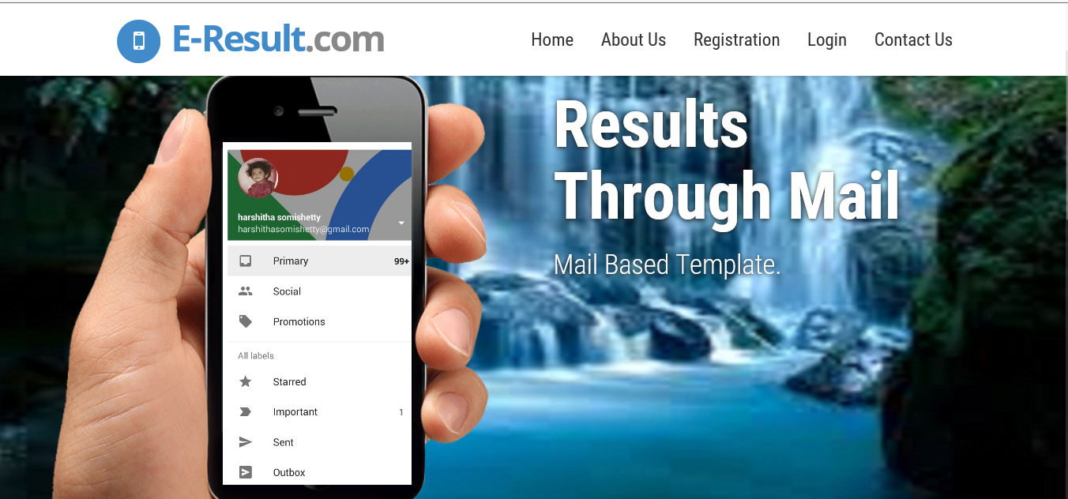
Fig : Home Page
Login Page: In the Login Page it has their respective ID & Password for the users. The users can login their ID for their home page and they can check the status.
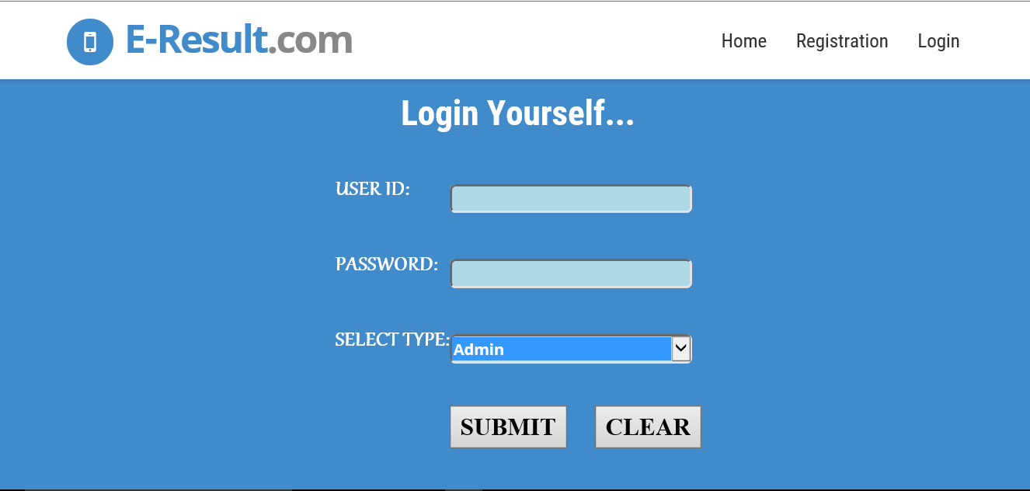

Fig: Login Page
Register Page: In the Register Page, student have to register the details of the students to check their results.In this system it is designed for registration of the student details. This is useful to enter the fee details. The student Enroll page is designed for the entering the student details . After entering the details it will shown as successful. The system requires small amount of time to be generate reports needed to manage the results of the students. Stay up-to-date of results for any period of time.

Fig : Register Page

IV.IMPLEMENTATION

Implementation is the stage in the project where the theoretical design is turned into a working system and is giving confidence on the new system for the users, which it will work efficiently and effectively. It involves careful planning, investigation of the current System and its constraints on implementation, design of methods to achieve the change over, an evaluation, of change over methods. Implementation is the final and important phase, the most critical stage in achieving a successful new system and in giving the users confidence. That the new system will work be effective .The system can be implemented only after through testing is done and if it found to working according to the specification. This method also offers the greatest security since the old system can take over if the errors are found or inability to handle certain type of transactions while using the new system.
The E-Results is designed to work as an online application or software. The system is designed to have a point of Entry which is to be used by the Administrator with the login privilege and role granted. The Administrator is responsible for the following: registration of students, result upload for registered students and generating alert reports to all concerned students when new result updates are available. These alerts would be sent to the email the student provided at the point of registration. This system are designed using the following: HTML programming language, Javascript, Css, HTML is the key language used in the development of the webpage.

Html is a script language for designing a web application. It has feature that comfortably aids the programming of the various tasks needed in developing a dynamic web application. Cascading style sheet came into play in giving the interface an aesthetic look. The database of the system is designed using ORACLE. ORACLE is particularly popular for use with websites that are designed using HTML For the system perform its proposed function, which is Sending results to students via Email technology. The system takes the messages to the message gateway which is going to be outsourced to another server. On the side of email, the system simply composes the text message and sends the result to target email address. However, in both cases reliable internet connection is a key factor for this process to work as expected.

V.Conclusion & FUTURE WORk
In previous system, we do not get result at a time. In our proposed system, the result will send via E-mail. This is an innovative addition in the education sector. It makes the availability of results easier and efficient for access. Digital scheme are used with help of Email relevant in education sector. This system gives result through the Email. In previous system, result may be not shown by the students because of poor internet speed. Many students are not aware of when the result has been declared. In proposed system this all drawbacks are cover and so that students can easily get the result via Email without being a part of poor internet speed or connection. Students simply get their result by text mode on their respective mobile phones and by their Email Id.
In future we can use for events notification and voice call also will be send of 30-40 sec as alert andWeb application will be used for big institute or firm.
V1.REFERENCES
[1] Jacobs, M L. (2009) Libraries and the mobile revolution: remediation = relevance. 37 (3) pp. 286-290.
[2] Murthy, M. V. R. (2008). Mobile based primary health care system for rural India. W3C workshop on Role of Mobile Technologies in Fostering Social Development, Jun 2008.
[3] Wavecom,“AT Commands Interface Guide for AT x41”, September 2004, http://www.wavecom.com.
[4] DISASTER PREPAREONESS FOR THE FAMILY.3rd Edition-Updated & Expanded Arthur T: Bradley,ph.D
[5]A.Priyadarshni,N.Deepthi,S.Divya,AswaniKumar. “Guide=A System for Mobile Information System”.
[6] “Field Data Collection Over SMS For Live Television News Broadcast”,Vender IG LogixSoftechPvt Ltd. Private published(www.imrbint.com).
[7] JeunghyunByun, Seung-Wook Lee, Young-In song. Hae-Chang Rim”Two Model for SMS Text Messages Refinement”, The Messages AAAI 2008 Workshop on Enhanced Messaging,2008.
[8] Wavecom, “AT Commands Interface Guide for AT x41”, September 2004, http://www.wavecom.com

