**TRANSPARENT SMARTPHONES**

Polytron technologies Inc.USA

**Abstract:** Transparent smart phones allow us to see through the phone and what’s being displayed on the glass screen. This technology has been around in the past two to three decades. But only since 2012 it’s being incorporated by the corporate companies like Samsung, Planar systems etc.

These smart phones will enhance our views of the world with digital images overlaid on the real ones. Fully transparent smart phones are developed by Taiwanese company “Polytron Technologies”, giving us hope for fancy smart phones far different from common models seen these days.

**Key words**: transparent display, OLED, glass technology, switchable glass, dual sided, multi touch.

**Introduction:**

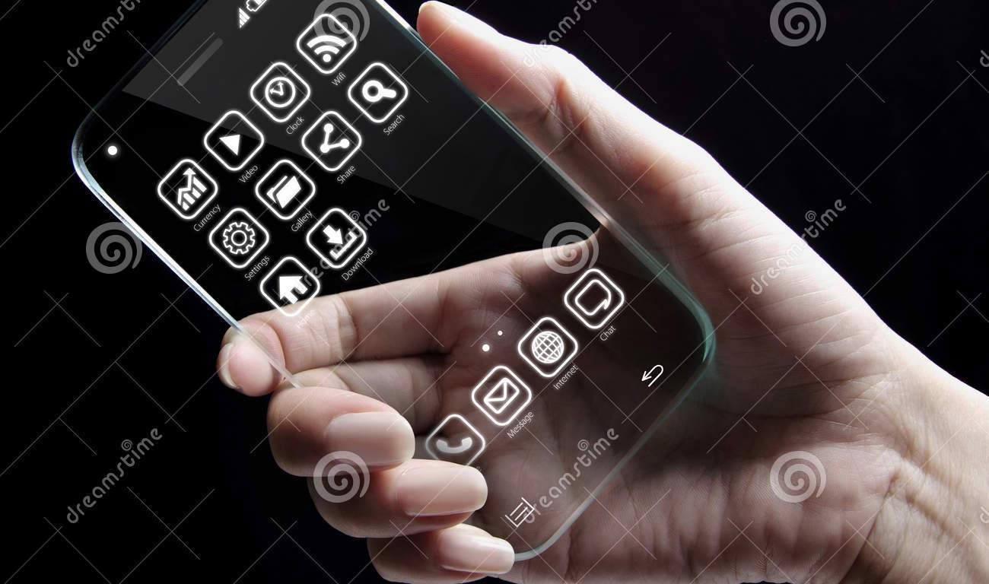

Advancement and innovation have brought about continuous changes and development in the world of Information Technology. Aside from the technical details, parts, and bits required to construct a technological device, appearance is a crucial aspect of technologies in that they enhance the overall look of those devices. A high-class, professional look promotes selling in the market because customers go for a device that is attractive and functional all-together. Many different phone models, particularly speaking, smart phones, exist today. Perhaps the leading brands of them are I phone, Samsung, and HTC. These companies compete with each other in designing the sleekest-looking model that supports the same number and types of capabilities.

One emerging technology is the new transparent Smartphone with a multi-touch display. This phone simply looks like a block of transparent glass; however, it can carry out the same functions as the existing smart phones.

A glass industry, Polytron Technologies, Inc. expects this technology to be released into the market by the end of the year 2013 (Polytron). The technology used to build the transparent

Smartphone is unique and an outstanding concept because it will allow end-users experience multi-touch display on a different level.

When the phone is off the molecules align to form a milky composition, but when switched on they realign to form text, icons, and other images.

Electric current is carried through transparent wires.

The device still has some parts that are not transparent, including a SD card and SIM card. The microphone, camera, and batteries are also visible, and will be hidden behind a dark glass cover when the model goes into production.

**World’s first transparent mobile phone:**

The concept of a transparent mobile phone is nothing new. We’ve seen it in countless sci-fi movies and TV shows. However, Polytron has now created a working prototype of a transparent mobile phone.

Polytron, a Taiwan based company has created a phone that is fully transparent and only the circuit board, memory card and camera unit is visible. It is a touch screen phone that has a fully functional SIM tray, SD card slot, microphone and camera. However, the phone does not yet have an operating system.

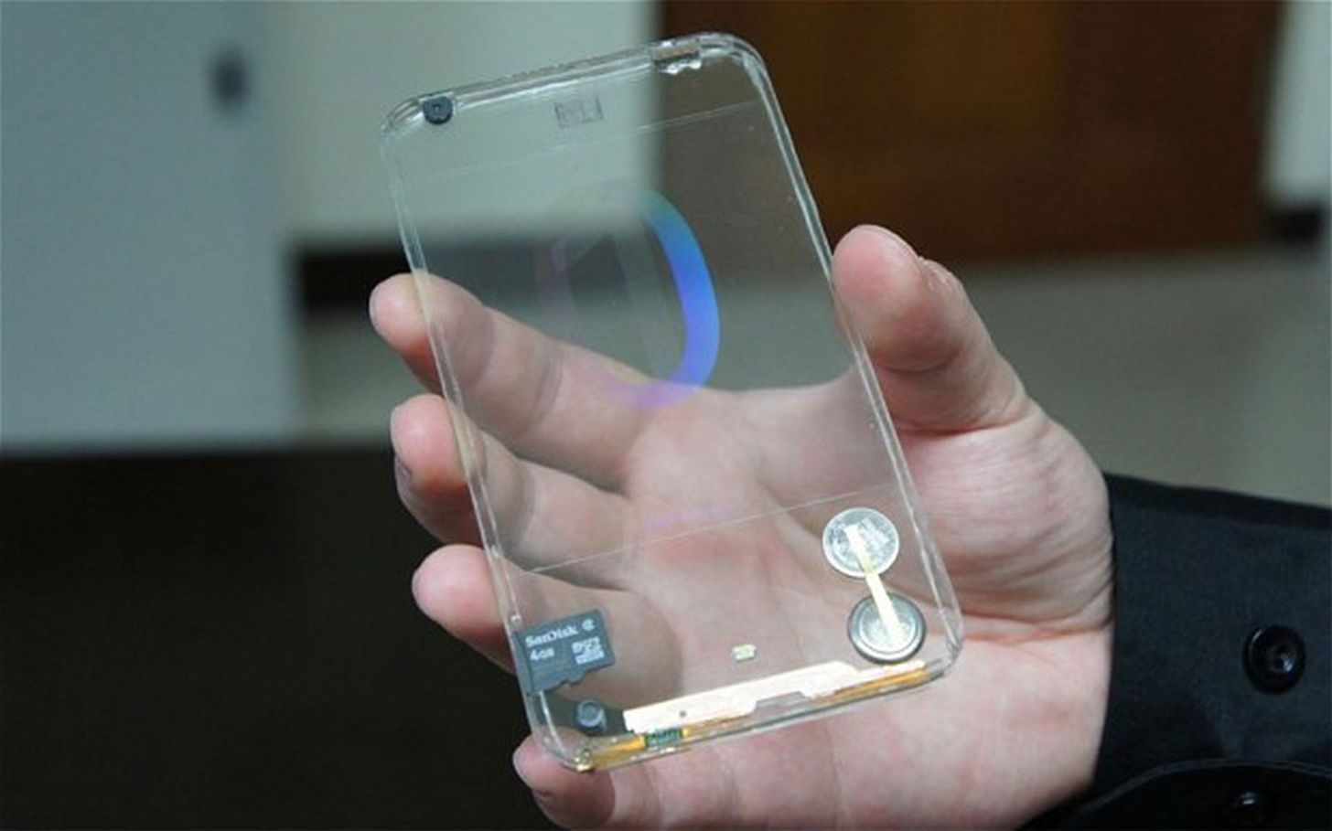

Fig: Cutting edge-phone uses a technology called switchable glass & liquid crystal to display images

**Hardware & software:** Based on the proposed interactions, an actual transparent- display mobile device requires the following capabilities:

*Transparency* – the capacity to see both the digital content and the world behind it. The display material plays a pivotal role on transparency and colour perception [32].

*Dual-sidedness* – the capacity to see and interact with the display from either side. The challenge is to determine the active side and to classify touch as *front* or *back* input*.*

*Orientation and Side Detection:* The Arduino processes the accelerometer data to determine the interaction side (front-up or front-down) at 100 FPS

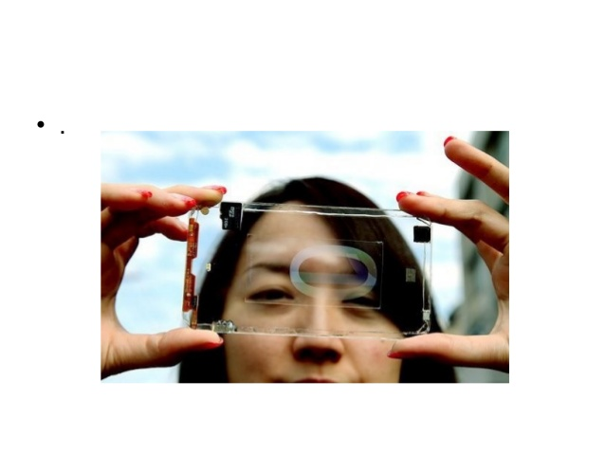

. Figure 7-TopLeft shows the orientation vectors when holding the device at different angles with the side of interaction facing up. Similarly, Figure 7-TopRight shows the orientation vectors for the reverse side.

Note the inverse orientation of values for the Z component (black trace). We used the Z component to determine the side, with a smoothing filter of 50 frames to reduce false side detections.

Once a side is detected the Arduino board communicates it to the computer and signals the multiplexers. When the device is in the front-down position, the computer flips the graphics horizontally (appearing correctly to the viewer), and enables the bottom and disables the top touch sensors. 

Fig. Angle readings (Z in black) for front up (left) and front down (right) bottom: board schematics

**Background:**

Polytron Technologies, Inc. is the world’s grand-leading manufacturing industry of optical vision and electronic glass. Polytron Technologies, Inc. already has various high-quality products such as Polyvision Privacy Glass, Polymagic LED Glass, Polyholo Glass, PolyGlow Glass, and much more (Polytron). To get a glimpse of how experienced and developed Polytron Technologies is, take a look at the Polyvision Privacy Glass product.

A switch controls the state of the glass; when the switch is operated, the glass changes from transparent state to a state of a cloudy translucent glass which gives privacy to the room or area that is surrounded by that glass (Polytron). Recently, Polytron Technologies introduced its new “Switchable Glass” technology which is the foundation for the transparent Smartphone technology (Polytron). This “Switchable Glass” technology consists of an OLED (organic light-emitting diode) screen which can display bright, sharp images more than LCDs (liquid crystal display) do.

The OLED screen utilizes the liquid crystal molecules in order to display the images and what not (Owano 2013). This feature sets the base for the further development of the rest of the features needed to complete the transparent Smartphone project.

 Since Polytron Technologies already has working glass technologies, Polytron is able to take on this transparent Smartphone project.

Polytron Technologies, Inc. based in Taiwan first came up with the project concept of developing a transparent Smartphone. The current model that exists is merely a prototype version. This model has the installed battery, speakers, SD cards, and built-in camera (Tsukayama 2013). Of course, these features are visible; however, Polytron’s goal is to cover these once the model is fixed with all else and incorporate the features of multi-touch display and release the product into the market. Like the way the Polyvision Privacy Glass works, the transparent Smartphone will work the same way. If the phone is not turned on, then the molecules within the glass will change to a cloudy state, meaning it will no longer be that transparent.

Once the phone is turned on, the electric current works to display images and such on the OLED display screen (Rundle 2013). The key to Polytron's prototype is its so-called Switchable Glass technology — a conductive OLED that uses liquid crystal molecules to display images

. When the phone is powered off, these molecules form a white cloudy composition, but once activated with electric current (flowing through transparent wires), they realign to form text, icons, or other imagery.

**Potential benefits:**

  Once this technology successfully passes testing and is released into the market, it is guaranteed to boost the sales in the market and surpass the levels of other smart phones. First off, this technology will incorporate the glass technology with its multi-touch display screen to create a device with high-end capabilities. This device will have a touch screen that works on both sides of the phone and this is particularly useful for more interaction with apps and directing on the phone’s touch screen. Users will be able to have a more fixed control of tasks on the phone such as scrolling.

Now, given the sleek, classy, and professional look of this device put together, customers will certainly appreciate the beauty of the glow of the transparent glass. Appearance is another major requirement for technical people. How their devices look should reflect the complexity of their doings. Even though all components of the device are not transparent, such as the battery, speakers, and SD cards, the rest of the device finishes off real well.

The dimensions of this technological device is said to be slimmer than the iPhone 5 (Tsukayama 2013). Engineers are able to pack the tiny components together so they can achieve that slim size for this device (Danigelis 2013). With a slim size comes a light-weight product. Customers absolutely benefit from this feature because they will not have to face the burden of carrying around a device that is highly technical and weighs too much. The size and weight allows for ease of transportation and this glass is durable.

 Some people are constantly using their smart phones while walking, especially on busy streets. They tend to lose focus of what is going on around them and this causes accidents. With the transparent glass Smartphone, one can multitask safely without running into stop signs or other people (Toor 2013).

The transparent glass ensures this because one can see through the phone. This is an especially important benefit because it eliminates distraction. Moreover, there is even an app called “Transparent Screen” for current smart phones (Toor 2013). This app adjusts the light and image display so that the user can simultaneously carry out phone tasks while knowing what’s going on outside the phone (Google App).

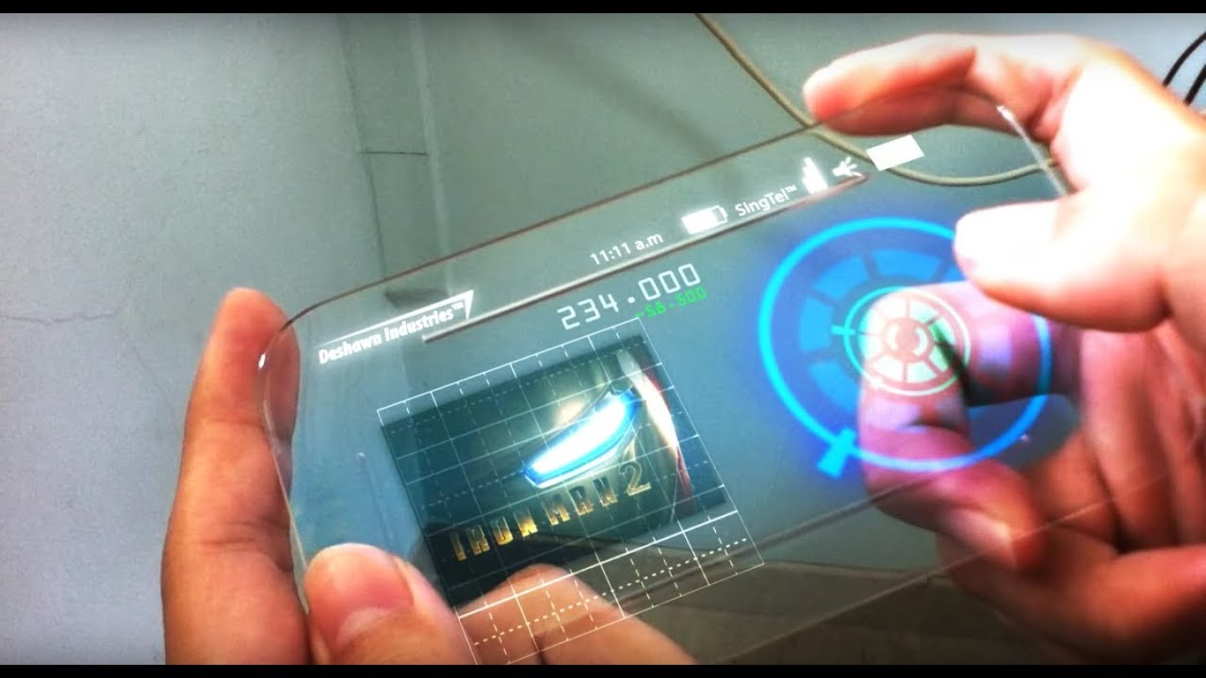

**Multi tasking experiment:**



**Figure 2. Information seeking experiment. A) Starting point. B) Finding the target application. C) Collecting the data.**

The number of apps varied from 1 to 3. Distance was random between 0 and 3. Participants trained with each condition after the experimenter had demoed the task. With a total of 4×3 = 12 conditions and 6 trials per condition, we registered 4×3×6 = 72 trials (each trial consisted of 3 selections) or 216 selections per participant. We used a Latin-square design to counter-balance the conditions. The experiment lasted approximately 30 minutes.

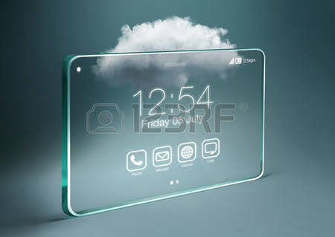

Fig. Good looking: noticeable hardware will be covered with a dark glass to keep to keep the phone aesthetically pleasing

On mobile devices, nearly 30% of tasks involve multiple applications with severe switching costs

Current devices support multitasking via Apple’s iPhone multitask bar and its equivalent in Android and Windows devices. In this experiment we evaluated the performance of *flipping* and *tap’n flip* on an information seeking task involving multiple apps. *Flipping* allows two applications to run on different sides, where one of them is the main application and the other the information source. *Tap’n flip* simplifies data transfer between apps by copy/pasting the tapped contents onto the other side.

*Task –* The experiment application asks users to ‘collect’ a number from another app (Figure 2a).

Users navigate to the target application, collect the number, and navigate back to the experiment application. Figure 2 shows the process when the requested information is in the Red7 app. Information sources are organized by the distance from the main application, *blue* applications are on the same screen, while *red* applications are three screens away. A task consists in finding 3 numbers

*Design* – Independent variables were switching *method* and *number of applications*. Application distance was a random factor.

Here four switching methods: *home* (H – a button push shows the main screen), *multitasking bar* (MB – a button push shows the main screen and the recently used apps at the bottom – Figure 2b), *flipping* (F) and *tap’n flip* (TF).

**How it works:**

**LCD DISPLAYS:**

This technology can’t be seen through because of their thickness and due to their inability to emit light on their own. But the liquid crystal technology can be used by backlighting. When power is off, the liquid crystal molecules are in a random orientation and scatter the incident light. And when power is on, the molecules arrange themselves in a line and allow the light to pass through them. 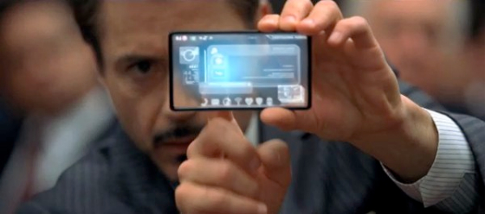

This technology is the cheap alternative to the OLED technology.

Researchers are also working to develop the transparent devices using Nano Technology.

LCD see-throughs do not produce their own light but only modulate ambient light. LCDs intended specifically for see-through displays are usually designed to have improved transmission efficiency.

Transparent smart phones are being designed using the OLED and LCD technologies.

OLED technology:

Organic light-emitting diode (OLED) has an emissive electroluminescent layer made of organic compound which emits light in response to electric current. This layer is placed in between two electrodes made of organic semiconductors, at least one of the electrodes being transparent. This has an emissive and conductive layer where the electric impulse travels from conductive layer to the emissive layer.

This is the most commonly employed technology in transparent devices and digital displays.

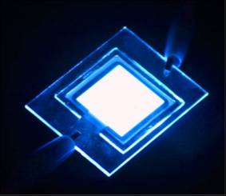

Prototype of OLEDs

LED screens have two layers of glass on both sides of a set of addressable [LEDs](https://en.wikipedia.org/wiki/LED). Both inorganic and organic ([OLED](https://en.wikipedia.org/wiki/OLED)) LEDs have been used for this purpose.

 OLEDs consist of an emissive and conductive layer. Electrical impulses travel through the conductive layer and produce light at the emissive layer. This is different from [LCDs](https://en.wikipedia.org/wiki/LCD) in that [OLEDs](https://en.wikipedia.org/wiki/OLED) produce their own light, which produces a markedly different visual effect with a see-through display.

**Current technology utilizing**

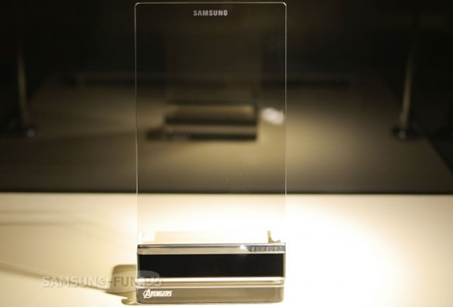

Samsung LCD transparent see through display

**Legal & ethical issues:**

Although this emerging technology has yet to deep-root its complete functionality, legal and ethical issues may not arise because this project uses glass technology as the base and all else is existing approved features of a regular Smartphone.

**Security concerns:**

Where ever the word, “transparent”, exists, privacy never exists. In fact, it is not just privacy that does not exist, security does not as well. Although when the transparent glass Smartphone is switched off the phone is in a cloudy conformation, when the phone is turned on, everything is transparent (Toor 2013).

When one unlocks one’s phone, everyone else around the person can see the code if they tried because there is nothing to block the view from others.  Next, browsing through safari, looking at pictures, reading emails, accessing apps and much more are also public.

Whenever one uses the phone in public, anyone can see what is going on (Toor 2013). This is a major intruding on one’s security because everything is visible.

**See-through displays:**

### Samsung

[Samsung](https://en.wikipedia.org/wiki/Samsung) has designed and marketed several see-through display products, the most notable being the Samsung Smart Window. The Smart Window is a transparent LCD meant to act as both a window and smart device capable of using apps and widgets, as well as connecting to the internet.

### Planar Systems

Planar also develops display cases similar to Samsung for stores. In addition, they develop transparent displays for use in vehicles as [heads-up displays](https://en.wikipedia.org/wiki/Heads-up_display) that can show speed and other information such as alerting the user to incoming dangers more quickly and efficiently.

### Taptl

Taptl develops, manufactures and sells transparent touch-screens. The touch-screens can be used as windows, kiosks, directories, "TVs," or computers for personal or business use. The technology is currently being marketed to the luxury interiors industry, including retail, yachts, aircraft, and homes. They are offered in sizes 5"-110", available in HD and UHD, and are environmentally sustainable, with endless applications

The technology being used in the phone is called Polyvision Privacy Glass. It allows a device to turn transparent when an electric current is passed through it. They’ve also used microscopic wires that have been fed directly into the glass that make it barely visible to the naked eye. We’ve seen similar examples in the glass strip on the Sony XPERIA Z, XPERIA P and XPERIA U.

**Social problems:**

Social issues refer to problems which may directly or even indirectly affect others. Social problems relate to privacy problems because in the end, they affect the public. Since this transparent glass Smartphone will be completely transparent, the public will be affected in such a way that they do not want others to know what they are doing on their phone. Also, if this glass phone falls down and shatters, there is a chance of injuring people around because glass is injurious and this concerns the safety of people.

Another social problem is that it requires well-maintained concentration and focus in using such an advanced technology. Elder people will face difficulty in handling this device because there will be too much going on and this can cause stress and mental health problems (Mental Health Technologies 2010).

**Future required research:**

 For this transparent glass Smartphone to be launched into market by the end of the year 2013, engineers will have to conduct further research regarding speed, lifetime, and functional capabilities of this Smartphone. Engineers have to find a way to put together all the components and parts of the phone in this sleek model size because of the size of application data and memory.

Also, with such a sleek design, the speed will have to at least match the speed of the smart phones that are out in market today. As discussed before, some components of the Smartphone are still visible and to achieve the goal of a transparent glass Smartphone, engineers will have to develop a new way to cover those components as well.

 Customers will not be satisfied with this as it is concerning to their everyday life. Customers will be forced to use this technology in their limits to decrease chances of someone finding out what apps they use on the phone, passwords to important accounts, and so forth.

**Uses:**

1. 1. **This technology has the best use in case of augmented reality**.

Transparent devices have much more resolution and displays much more realistic augmented video than which takes the video and adds the supplements and then displays back on to our screens.

1. 2**. In text translation:**

Generally when the user points the camera to a sign board in one language and it automatically gets translated into the language of the user choice.

But in the case of transparent devices there is no need to use the camera.

1. 3. **In street view:**

The technology is similar to that of Google street view.

1. 4. **In shopping windows:**

Here the user can see the item and the corresponding details of it at the same time.

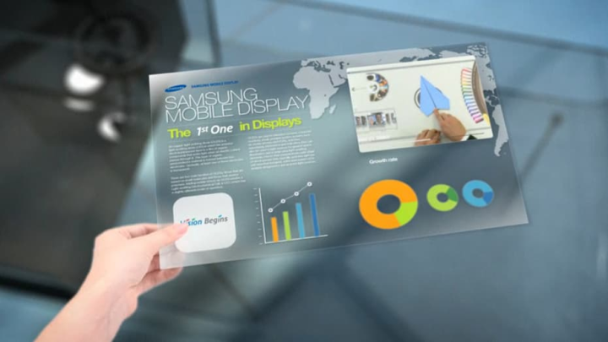

**References:**

Source #1:

Polytron. Polytron Technologies, Inc. Company Info. Retrieved May 19th, 2013, from <http://www.polytron.com.tw/>.

Source #2:

Nancy Owano. (February 17th, 2013). Polytron predicts glass smart phones by end of year. Retrieved May 19th, 2013, from <http://phys.org/news/2013-02-polytron-glass-smartphones-year.html>.

Source #3:

Michael Rundle. (February 18th, 2013). Polytron Technologies Unveils Transparent Phone. *In Huffington Post.* Retrieved May 19th, 2013, from <http://www.huffingtonpost.co.uk/2013/02/18/polytron-technologies-transparent-see-through-phone-video_n_2709136.html>.

Source #4:

Hayley Tsukayama. (May 16th, 2013). Google Details on What Glass Can Do. *In Washington Post.* Retrieved May 19th, 2013, from <http://www.washingtonpost.com/business/technology/google-io-google-offers-more-details-on-what-glass-can-do/2013/05/16/20ae979a-be52-11e2-97d4-a479289a31f9_story.html>.

Source #5:

Alyssa Danigelis. (April 26th, 2013). Transparent Phone Screen Prevents Collisions. *In Discovery.* Retrieved May 19th, 2013, from <http://news.discovery.com/tech/apps/transparent-phone-screen-prevents-collisions-12020.htm>.

Source #6:

Amar Toor. (February 15th, 2013). Has the Transparent Smartphone Finally Arrived?. *In The Verge.* Retrieved May 19th, 2013, from http://www.theverge.com/2013/2/15/3966950/will-we-see-a-transparent-phone-polytron-prototype-display.

 Lastly, in order to respond to the basic concerns of privacy and security, engineers working with Polytron Technologies, Inc. will need to research a way to make it so that only the end-user of the phone can see what occurs on the phone and no one else can see that view.

**Conclusion:**

 Polytron Technologies, Inc. is an astounding company with brilliant products and they are currently working on a new project: “Switchable Glass” Technology. This technology will be the base foundation for the creation of the transparent glass Smartphone which is the new topic of the market.

This Smartphone will incorporate the glass technology and use OLED screen display which has liquid crystal molecules to display images and text.

This phone has a new look, including the light-weight, slim design. Customers will appreciate the new design which includes a double-sided touch-screen. The current prototype is a just preview of the future product which is targeted to be released by the end of this year. With the bringing of this technology, there will be no need for other Smartphone developments and this will save a lot of money for upgrading in the Information Technology world.

This emerging technology will allow users to use a glass technology with advanced technical features for the first time ever.