**UNDER WATER WIRELESS COMMUNICATION SYSTEM**

# Abstract

While wireless communication technology today has become part of our daily life, the idea of wireless undersea communications may still seem far-fetched. However, research has been active for over a decade on designing the methods for wireless information transmission underwater. Human knowledge and understanding of the world’s oceans, which constitute the major part of our planet, rests on our ability to collect information from remote undersea locations.

The major discoveries of the past decades, such as the remains of Titanic, or the hydro-thermal vents at bottom of deep ocean, were made using cabled submersibles. Although such systems remain indispensable if high-speed communication link is to exists between the remote end and the surface, it is natural to wonder what one could accomplish without the burden (and cost) of heavy cables.

Hence the motivation and interest in wireless underwater communications. Together with sensor technology and vehicular technology, wireless communications will enable new applications ranging from environmental monitoring to gathering of oceanographic data, marine archaeology, and search and rescue missions.

# Introduction

While wireless communication technology today has become part of our daily life, the idea of wireless undersea communications may still seem far-fetched. However, research has been active for over a decade on designing the methods for wireless information transmission underwater. Human knowledge and understanding of the world’s oceans, which constitute the major part of our planet, rests on our ability to collect information from remote undersea locations.

The major discoveries of the past decades, such as the remains of Titanic, or the hydro-thermal vents at bottom of deep ocean, were made using cabled submersibles. Although such systems remain indispensable if high-speed communication link is to exists between the remote end and the surface, it is natural to wonder what one could accomplish without the burden (and cost) of heavy cables.

Hence the motivation, and interest in wireless underwater communications. Together with sensor technology and vehicular technology, wireless communications will enable new applications ranging from environmental monitoring to gathering of oceanographic data, marine archaeology, and search and rescue missions.

Underwater wireless communication is a flourishing research area in the field of wireless communications. This paper presents the overall framework of the necessity of underwater wireless systems, characteristics of an acoustic channel, hardware and working of acoustic modems, sensor networks and different communication architectures involved in the sensor networks. Applications till date, like oceanographic data collection,AUVs(autonomous underwater vehicles),underwater radio etc.., future challenges like effective transmission of video and audio signals by real time monitoring have been emphasized with a view to overcome the present limitations.

# Acoustic modem

Acoustic modem technology today offers two types of modulation/detection: frequency shift keying (FSK) with noncoherent detection and phase-shift keying (PSK) with coherent detection. FSK has traditionally been used for robust acoustic communications at low bit rates (typically on the order of 100 bps). To achieve bandwidth efficiency, i.e. to transmit at a bit rate greater than the available bandwidth, the information must be encoded into the phase or the amplitude of the signal, as it is done in PSK or quadrature amplitude modulation (QAM). For example, in a 4-PSK system, the information bits (0 and 1) are mapped into one of four possible symbols, ±1±j.

The symbol stream modulates the carrier, and the so-obtained signal is transmitted over the channel. To detect this type of signal on a multipath-distorted acoustic channel, a receiver must employ an equalizer whose task is to unravel the inter symbol interference. Since the channel response is not a-priori known (moreover, it is time-varying) the equalizer must “learn” the channel in order to invert its effect. A block diagram of an adaptive decision-feedback equalizer (DFE) is shown in Figure 3. In this configuration, multiple input signals, obtained from spatially diverse receiving hydrophones, can be used to enhance the system performance. The receiver parameters are optimized to minimize the mean squared error in the detected data stream. After the initial training period, during which a known symbol sequence is transmitted, the equalizer is adjusted adaptively, using the output symbol decisions. An integrated Doppler tracking algorithm enables the equalizer to operate in a mobile scenario.

This receiver structure has been used on various types of acoustic channels. Current achievements include transmission at bit rates on the order of one kbps over long ranges (10-100 nautical miles) and several tens of kbps over short ranges (few km) as the highest rates reported to date. On a more unusual note, successful operation was also demonstrated over a basin scale (3000 km) at 10 bps, as well as over a short vertical channel at a bit rate in excess of 100 kbps. The multichannel DFE forms the basis of a high-speed acoustic modem implemented at the Woods Hole Oceanographic Institution. The modem, shown in Figure 4, is implemented in a fixed-point DSP, with a floating-point co-processor for high-rate mode of operation. When active, it consumes about 3 W in receiving mode, and 10-50 W to transmit.

The board measures 1.75 _ 5 in, and accommodates four input channels. The modem has successfully been deployed in a number of trials, including autonomous underwater vehicle (AUV) communications at 5 kbps.



Fig. 4: The WHOI micromodem

has dual mode of operation: low

# under water networks

With advances in acoustic modem technology, sensor technology and vehicular technology, ocean engineering today is moving towards integration of these components into autonomous underwater networks. While current applications include supervisory control of individual AUVs, and telemetry of oceanographic data from bottom-mounted instruments, the vision of future is that of a “digital ocean” in which integrated networks of instruments, sensors, robots and vehicles will operate together in a variety of underwater environments. Examples of emerging applications include fleets of AUVs deployed on collaborative search missions, and ad hoc deployable sensor networks for environmental monitoring.



Fig. 5: Centralized network topology



Fig. 6: Decentralized network topology.

Depending on the application, future underwater networks are likely to evolve in two directions: centralized and decentralized networks. The two types of topologies are illustrated in Figure 5 and Figure 6. In a centralized network, nodes communicate through a base station that covers one cell. Larger area is covered by more cells whose base stations are connected over a separate communications infrastructure.

The base stations can be on the surface and communicate using radio links, as shown in the figure, or they can be on the bottom, connected by a cable. Alternatively, the base station can be movable as well. In a decentralized network, nodes communicate via peer-to-peer, multi-hop transmission of data packets. The packets must be relayed to reach the destination, and there may be a designated end node to a surface gateway. Nodes may also form clusters for a more efficient utilization of communication channel.

To accommodate multiple users within a selected network topology, the communication channel must be shared, i.e. access to the channel must be regulated. Methods for channel sharing are based on scheduling or on contention. Scheduling, or deterministic multiple-access, includes frequency, time and code-division multiple-access (FDMA, TDMA, CDMA) as well as a more elaborate technique of space-division multiple access (SDMA).

Contention-based channel sharing does not rely on an a-priori division of channel resources; instead, all the nodes contend for the use of channel, i.e., they are allowed to transmit randomly at will, in the same frequency band and at the same time, but in doing so they must follow a protocol for medium-access control (MAC) to ensure that their information packets do not collide. All types of multiple-access are being considered for the underwater acoustic systems.

Experimental systems today favor either polling, TDMA, or multiple-access collision avoidance (MACA) based on a hand-shaking contention procedure that requires an exchange of requests and clearances to send (RTS/CTS). Intelligent collision avoidance appears to be necessary in an underwater channel, where the simple principle of carrier sensing multiple access (CSMA) is severely compromised due to the long propagation delay—the fact that the channel is sensed as idle at some location does not guarantee that a data packet is not already in transmission at a remote location.

one of the major aspects of the evolving underwater networks is the requirement for scalability. A method for channel sharing is scalable if it is equally applicable to any number of nodes in a network of given density. For example, a pure TDMA scheme is not scalable, as it rapidly looses efficiency on an underwater channel due to the increase in maximal propagation delay with the area of coverage. In order to make this otherwise appealing scheme scalable, it can be used locally, and combined with another technique for spatial reuse of channel resources. The resulting scheme is both scalable and efficient; however, it may require a sophisticated dynamic network management.

In contrast, contention-based channel allocation offers simplicity of implementation, but its efficiency is limited by the channel latency. Hence, there is no single best approach to the deployment of an underwater network. Instead, selection of communication algorithms and network protocols is driven by the particular system requirements and performance/complexity trade-offs.



Fig. 7:A deep-sea observatory.

Research today is active on all topics in underwater communication networks: from fundamental capacity analyses to the design of practical network protocols on all layers of the network architecture (including medium access and data link control, routing, transport control and application layers) as well as cross-layer network optimization.

In addition to serving as stand-alone systems, underwater acoustic networks will find application in more complex, heterogeneous systems for ocean observation. Figure 7 shows the concept of a deep sea observatory.

At the core of this system is an underwater cable that hosts a multitude of sensors and instruments, and provides high-speed connection to the surface. A wireless network, integrated into the overall structure, will provide a mobile extension, thus extending the reach of observation. While we have focused on acoustic wireless communications, it has to be noted that this will not be the only way of establishing wireless communication in the future underwater networks.

Optical waves, and in particular those in the blue-green region, offer much higher throughput (Mbps) albeit over short distances (up to about 100 m). As such, they offer a wireless transmission capability that complements acoustic communication.

**NECESSITY OF UNDERWATER WIRELESS SYSTEM:**

Wired underwater is not feasible in all situations as shown below.

* Temporary experiments
* Breaking of wires
* Significant cost for deployment
* Experiment over long distances

**UNDERWATER ACOUSTIC CHANNEL**

* Severe multipath- 1 to 10msec. for shallow water at upto 1 km range
* Doppler shifts
* Long latencies-speed of sound underwater is approximately 1500m/sec

**ACOUSTIC MODEMS:**

The modems employ advanced modulation scheme and channel equalization to combat multipaths for improved signal to noise ratio. A high performance error detection and correction coding scheme is employed that reduces the bit error rate to less than 10-7

**PARTS OF AN ACOUSTIC MODEM:**

* **DSP BOARD(Digital Signal Processing Board):**

It serves both as signal processing module and a microcontroller.

* **AFE BOARD(Analog Front End Board):**

It performs signal filtering and amplification functions.

* **DC/DC CONVERTER:**

It converts a wide range of input voltage to the operating voltage of the system and the transducer.

**HARDWARE STRUCTURE:**

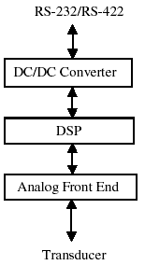

**WORKING PRINCIPLE:**

When no data is being transmitted, the modem stays in sleep mode thereby it periodically wakes

Up to receive possible data being transmitted by far end modem. This results in low power consumption.

**DATA TRANSMISSION IN MODEM:**

Suppose the bottom modem tries to send data to surface modem, it receives data from its link while it is in sleep mode and then it switches to the transmit mode and begins to transmit. As the surface modem wakes up and detects data from bottom modem, it switches from sleep mode to receive mode.

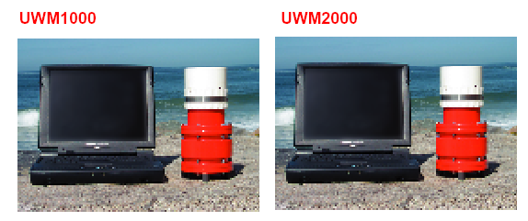

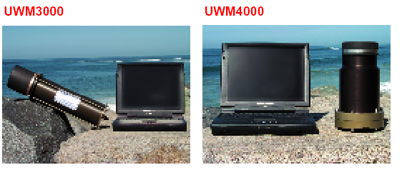

**UNDERWATER ACOUSTIC SENSOR NETWORKS:**

Underwater networks consist of a variable number of sensors and vehicles that are deployed to perform collaborative monitoring tasks over a given area. Traditional approach for ocean bottom monitoring is to deploy underwater sensors that record data and then recover the instruments. By this method real time monitoring is not possible, failures occur. This can be overcome by connecting underwater instruments by means of wireless links.

**UNDERWATER ACOUSTIC SENSOR NETWORKS COMMUNICATION ARCHITECTURE:**

**2-D ARCHITECTURE:**

* **Sensor nodes** are anchored to the bottom of the ocean with deep ocean anchors.
* By means of wireless acoustic links, underwater sensor nodes are interconnected to one or more **underwater sinks (UW-sinks)**.
* UW-sinks are equipped with **two acoustic transceivers**, **horizontal** and **vertical transceiver**. The first is used by the UW-sinks to communicate with the sensor nodes, while the second is used by the UW-sinks to relay data to a surface station.

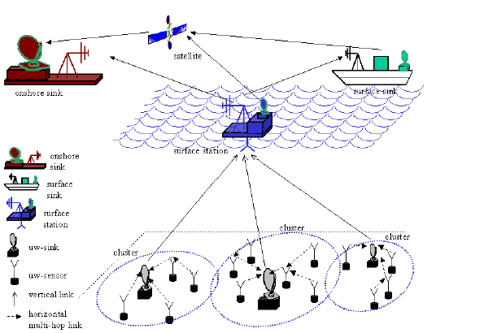

* **Vertical transceivers** must be long range transceivers for deep water applications. The **surface station** is equipped with **multiple acoustic transceivers**, one for each UW-sink deployed.
* It is also endowed with a **long range RF** or satellite transmitter to communicate with the **onshore sink** **(OS-sink)** or to a **surface sink (s-sink)**.
* Sensors can be connected to sinks by means of direct links or through **multi-hop paths**. In case of multi-hop paths, as in terrestrial sensor networks [4], data produced by a sensor is relayed by intermediate sensors until it reaches the UW-sink

**3-D ARCHITECTURE:**

* **Sensor nodes** float at different depths in order to observe a given phenomenon.
* The possible solution to achieve different depths would be to attach each UW-sensor node to a surface buoy, by means of wires.
* Multiple floating buoys may obstruct ships navigating on the surface.

They may also be easily detected and deactivated by enemies in military settings.

Due to the above reasons, each sensor is anchored to the ocean bottom and equipped with a floating buoy that can be inflated by a pump. The buoy pushes the sensor towards the ocean surface. The depth of the sensor can then be regulated by adjusting the length of the wire that connects the sensor to the anchor, by means of an electronically controlled engine that resides on the sensor.

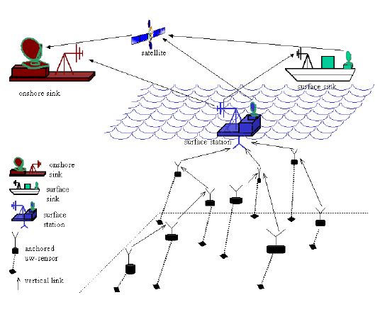

# Applications

* Future applications could enhance myriad industries, ranging from the offshore oil industry to aquaculture to fishing industries, she noted. Additionally, pollution control, climate recording, ocean monitoring (for prediction of natural disturbances) and detection of objects on the ocean floor are other areas that could benefit from enhanced underwater communications.
* Environmental monitoring to gathering of oceanographic data
* Marine archaeology
* Search and rescue missions
* Defence

**7.Advantages**

The advantages of the underwater wireless communication are as follows:

* Underwater wireless communication avoids the data spoofing.
* It avoids the privacy leakage.
* It has the parameter of monitoring the pollution.

# Conclusion

In this topic we overviewed the main challenges for efficient communication in under water acoustic sensor networks. We outlined the peculiarities of the under water channel with particular reference to networking solutions the ultimate objective of this topic is to encourage research efforts to lay down fundamental basics for the development of new advanced communication techniques for efficient under water communication and networking for enhanced ocean monitoring and exploration applications

* The aim of this is to build a acoustic communication
* This is not only the way for underwater communication
* By using optical waves which offers higher throughput (Mbps) over short distances (up to about 100 m)

# REFERENCES

[www.redtacton.com](http://www.redtacton.com)

[www.wikipedia.com](http://www.wikipedia.com)

[www.howstuffworks.com](http://www.howstuffworks.com)

V.KEERTHANA

IV-YEAR

ECE DEPARTMENT

SVITS COLLEGE