**PELTIER REFRIGERATOR**

# S.KURUMURTHY

Dept. of Mechanical Engineering, SVITS, Mahbubnagar, Telangana, India

# T. HARISH BABU

Dept. of Mechanical Engineering, SVITS, Mahbubnagar, Telangana, India

# *Abstract:* This work is the first step in the development of an electric field refrigeration unit. Cooling devices in the future may lose their compressor and coils of piping to become solid state. Refrigerators or air conditioners — rely on the properties of gases to cool and most systems use the change in density of gases at changing pressures to cool. The coolants commonly used are either harmful to people or the environment. Freon, one of the fluoro chloro carbons banned because of the damage it did to the ozone layer, was the most commonly used refrigerant. Now, a variety of coolants is available. Nevertheless, all have problems and require energy-eating compressors and lots of heating coils. We designed and constructed a Compressor Less Peltier Refrigerator with an interior cooling. The Peltier refrigerator was equipped with on/off control which was found to be adequate to meet the required precision of +/- 15 degrees Celsius put forth in the work requirements.

1. **INTRODUCTION**

Radiant cooling systems are generally chilled ceiling beams or panels, to take advantage of convective air cooling as well as mean radiant temperature. Because cool air sinks, a chilled ceiling beam will cool air that will sink and distribute itself through the space. Convection is more important for radiant ceiling panels and beams because, unlike radiant floors, no one will touch these surfaces. Because of this, they are sometimes simply called "chilled beams". However, radiant cooling systems can be located in floors as well. There are several good reasons designers should consider including radiant cooling systems in new buildings in any climate zones. Commercial buildings primarily cooled by radiant means are more comfortable than buildings cooled by traditional HVAC systems. The first costs for radiant systems are comparable with those for traditional variable-air-volume (VAV) systems, but their lifetime energy savings over VAV systems are routinely 25 percent or even more. Over the past decade, the number of radiant cooling systems designed, installed and commissioned in North America has increased dramatically. Radiant cooling systems are gaining exposure and popularity for a variety of reasons: Such as Energy efficiency, Superior comfort, Greater architectural flexibility, Reduced operating and maintenance costs and More effective control of ventilation Energy Efficiency.

There are primarily two types of radiant cooling systems:

**Chilled Slabs:**-These deliver cooling through the building structure, usually slab, and is also known as thermally activated building systems (TABS). Radiant cooling from a slab can be delivered to a space from the floor or ceiling. Floor cooling is similar to floor heating that has been used in Europe since last few decades

**Ceiling Panels:**- These deliver cooling through specialized panels. Systems using concrete slabs are generally cheaper than panel systems and offer the advantage of thermal mass while panel systems offer faster temperature control and flexibility. Below is the summary of comparison between Slab Integrated and Panel .A typical thermoelectric module consists of an array of Bismuth Telluride semiconductor pellets that have been carrier–either positive or negative–carries the majority of current. The pairs of P/N pellets are configured so that they are connected electrically in series, but thermally in parallel. Metalized ceramic substrates provide the platform for the pellets and the small conductive tabs that connect them.

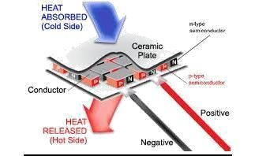

# Peltier Theory

When DC voltage is applied to the module, the positive and negative charge carriers in the pellet array absorb heat energy from one substrate surface

and release it to the substrate at the opposite side. The surface where heat energy is absorbed becomes cold; the opposite surface where heat energy is released becomes hot.

# Why is TE Coolers Used for Cooling?

No moving parts make them very reliable; approximately 105 hrs of operation at 100 degrees Celsius, longer for lower temps (Goldsmid,1986). Ideal when precise temperature control is required. Ability to lower temperature below ambient. Heat transport controlled by current input. Able to operate in any orientation. Compact size make them useful for applications where size or weight is a constraint. Ability to alternate between heating and cooling. Excellent cooling alternative to vapor compression coolers for systems that are sensitive to mechanical vibration.

**DISADVANTAGES**:- Able to dissipate limited amount of heat flux. Less efficient then VCR system. Relegated to low heat flux applications. And more total heat to remove than without a TEC.

# CHILLED SLABS

These deliver cooling through the building structure, usually slabs, and is known as thermally activated building systems (TABS). Radiant cooling from a slab can be delivered to a space from the floor or ceiling. Floor cooling is similar to floor heating that has been used in Europe since last few decades. Radiant cooling systems are generally chilled ceiling beams or panels, to take advantage of convective air cooling as well as mean radiant temperature. Because cool air sinks, a chilled ceiling beam will cool air that will sink and distribute itself through the space. However, delivering cooling from the ceiling has several advantages: It is easier to leave ceilings exposed to a room than floors, increasing the effectiveness of thermal mass. Floors have furniture, coverings and furnishings that decrease the effectiveness of the system. Greater convective heat exchange occurs through a chilled ceiling as warm air rises, leading to more air coming in contact with the cooled surface. Cooling delivered through the floor makes the most sense when there is a high amount of solar gains from sun penetration, as the cool floor can more easily remove those loads than the ceiling. Chilled slabs, compared to panels, offer more significant thermal mass and therefore can take better advantage of outside diurnal temperatures swings. Chilled slabs cost less per unit of surface area, and are more integrated with structure. Modern Radiant Cooling follows the same principle to cool a floor or ceiling (or even walls) by absorbing heat radiated by the rest of the room. As can be seen in the diagram below, a Cooled Ceiling acts as a heat sink for all radiant heat

sources in the room (human occupant, solar radiation, equipment, walls etc.).

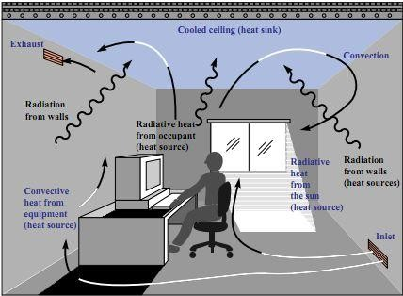

## Figure - Radiant Cooling from Ceiling

The latent loads (humidity) from occupants, infiltration and processes generally need to be managed by an independent system. Radiant cooling can also be integrated with other energy- efficient strategies such as night time flushing, indirect evaporative cooling, or ground source heat pumps.

# Advantages

Greater Architectural Flexibility With a radiant cooling system embedded in the floor slab, the visible components, such as air handlers, ductwork, grilles, diffusers, etc. can be much smaller, allowing greater flexibility in the aesthetic architectural design. The space requirements for the mechanical system (e.g., mechanical room, roof space, ceiling space for ductwork) can be compacted, potentially reducing building floor-to- floor heights. Additionally, because a radiant slab can much more effectively deal with direct solar loads, temperatures in areas with high fenestration (e.g., lobbies, atria, etc.) can be more easily controlled with less noise and draft. Relatively small temperature differences between the heated or cooled surface and the space are typical for TABS. This matter results in a significant degree of self control. In specific cases with low heating/cooling loads, a concrete slab can be controlled at aconstant core (water) temperature year round. If, for example, the core is kept at 72°F (22.2°C), then the slab will be space heating when room temperatures are below 22.2°C and space cooling when room temperatures are above 22.2°C.

# CEILING PANELS

Radiant cooling panels are generally attached to ceilings, but can also be attached to walls. They are usually suspended from the ceiling, but can also be directly integrated with continuous dropped ceilings. Modular construction offers increased flexibility in terms of placement and integration with lighting or other electrical systems. Lower

thermal mass compared to chilled slabs means they can’t easily take advantage of passive cooling from thermal storage, but controls in panels can more quickly adjust to changes in outdoor temperature. Chilled panels are also better suited to buildings with spaces that have a greater variance in cooling loads. Perforated panels also offer better acoustical dampening than chilled slabs. Ceiling panels are also very suitable for retrofits as they can be attached to any ceiling. Chilled ceiling panels can be more easily integrated with ventilation supplied from the ceiling. Panels tend to cost more per unit of surface area than chilled slabs. Cooling the ceiling is usually done in homes with radiant panels. Although potentially suitable for arid climates, radiant cooling is problematic for homes in more humid climates. Most radiant cooling home applications in North America have been based on aluminum panels suspended from the ceiling, through which chilled water is circulated. To be effective, the panels must be maintained at a temperature very near the dew point within the house, and the house must be kept dehumidified. In humid climates, simply opening a door could allow enough humidity into the home to allow condensation to occur.

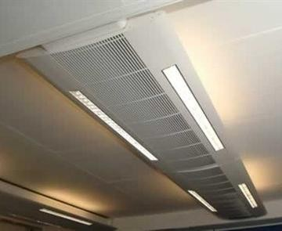

***Figure - Radiant cooling panel attached to ceiling***

The panels cover most of the ceiling, leading to high capital expense for the systems. In all but the most arid locations, an auxiliary air-conditioning system will be required to keep the home's humidity low, adding further to the capital cost. Some manufacturers do not recommend their use in homes. In addition, the limited U.S. experience with radiant cooling creates concerns about the quality and availability of professionals to install, maintain, and repair a residential system. Despite these caveats, there may be cases where radiant cooling is appropriate for homes, particularly in the arid Southwest.

# Principles of Radiant Cooling And Thermal Comfort

Whenever there is a temperature difference between two objects, both objects will attempt to equalize the temperature. The energy transfer required to approach equivalent temperatures

occurs through radiation, conduction and convection.

Radiant energy is infrared energy that travels from “hot” to “cold” through a space, without heating the space itself

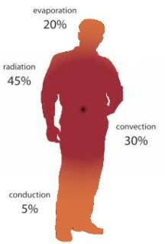

## Figure - Heat Transfer from Human body

Humans are exothermic heat generators. Heat emission from the human body occurs via four modes of heat transfer:

* Radiation (~45%)
* Convection (~30%)
* Evaporation (~20%)
* Conduction (~5%)

Our bodies radiate heat to any surface in line-of- sight which is cooler than our own surface temperature (85 - 90°F / 29 - 32°C). Humans feel most comfortable when they can regulate at least of their heat emission through radiation. Reducing surrounding surface temperatures draws more heat from our bodies via radiation. When the air is warm, this is a good thing.

# Mean Radiant Temperature(MRT)

According to ASHRAE (American Society of Heating , Refrigerating and Air - Conditioning Engineers) Standard 55-2010 defines six factors that affect thermal human comfort, They are:

* Air temperature,
* Radiant temperature,
* Humidity,
* Air velocity,
* Clothing and metabolism.

Since the latter two factors are occupant- dependent, only the first four can be monitored and controlled by the HVAC system. Traditional air conditioning systems typically only monitor and control three of these space conditions, ignoring radiant temperature.

Radiant heating and cooling systems address mean radiant temperature (MRT), which is a key factor in thermal comfort.

MRT is defined as the theoretical uniform surface Temperature of an enclosure in which an occupant would exchange the same amount of radiant heat as in the actual non-uniform enclosure. Unlike in an air-only system, the MRT in a radiant conditioned space recognizes the intimate relationship occupants have with The surroundings via radiant heat transfer.

This relationship is a key component in thermal comfort when integrated with air temperature to “operative temperature” indices as referenced in thermal comfort standards.

The operative temperature is numerically the average of the air temperature ta and mean radiant temperature tr, weighted by their respective heat transfer coefficients. Most requirements for comfort are based on the operative temperature in a space.

The operative temperature is calculated as:

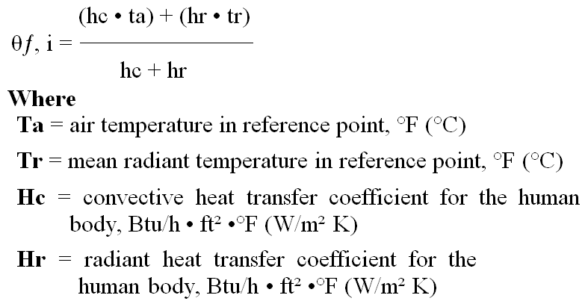

In most practical cases where the relative air velocity is small at <40 fpm (0.2 m/s) or where the difference between mean radiant and air temperature is small at <4°C, the operative temperature can be calculated with sufficient approximation as the average of air and mean radiant temperature.

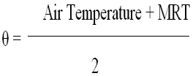

However, if the mean radiant temperature is significantly lower or higher than the air temperature, the convective and long-wave radiant heat flux should be calculated separately.

# Heat Transfer Basics

Heat transfer occurs whenever there is a temperature difference between two objects, and it continues until both objects are in thermal equilibrium.

According to a formulation of the Second Law of Thermodynamics known as the Clausius statement, heat cannot naturally flow from a colder temperature to a hotter temperature. In other words, heat will always naturally flow from hot to cold. Heat is transferred in three ways: conduction, convection and radiation. A

radiant cooling system uses all three modes of heat transfer.

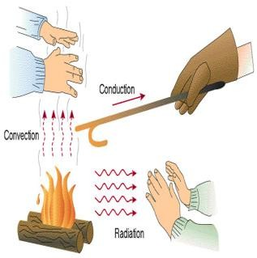

## Figure - Modes of Heat Transfer

**Conduction**

Conduction is heat transfer between two solids that are in direct contact with each other. In radiant heating and cooling systems, conduction occurs between the PEX-a tubing and the concrete slab. The heat transfer rate is based on the conductivity of materials, the tubing surface, and the temperature difference between the tubing and the slab. Conduction also occurs between the cooled slab and the objects in the space that are in contact with the slab, including air film, furnishings and occupants. If a person is standing on a cooled slab, then a quantity of body heat will naturally flow via conduction to the slab. The heat transfer rate is based on the cumulative R-values from footwear, the floor conductivity, and temperature difference between the occupant and the floor surface. To prevent discomfort due to temperature differentials, ASHRAE Standard 55-2010 recommends that floor slab temperatures be above 18.9°C for occupants wearing normal footwear in occupied spaces.

It should be noted that in temperature ranges typical of radiant floor cooling systems, and in consideration of footwear R-values, the amount of conductive heat transfer from foot to slab is relatively low and, therefore, typically considered negligible.

# Convection

Convection is heat transferred through a moving fluid or gas. In the case of radiant-based HVAC systems, natural or “free” air convection occurs due to differences in air densities influenced through contact with warmed or cooled surfaces. Natural convection is a design consideration with radiant- cooled ceilings as the layer of air in contact with the cool ceiling will drop due to its higher density, increasing air movement, and thus heat transfer, in the space. Forced convection occurs in the air handler, where fans are used to force the cooled air into the space. Because convection deals with heat transfer through the movement of air, the air temperature is directly affected.

# Radiation

The sensible heat transfer in a radiant cooling system is through radiation. Radiation is heat transfer through electromagnetic waves travelling through space. When the incident waves from a warmer surface come into contact with a cooler surface, the energy is absorbed, reradiated,

# Where

**Hcon** = convective energy exchange coefficient floor to space, Btu/ft **⋅**ºF, (W/m K)

**Hl,rad** = long - wave radiant energy exchange coefficient floor to space, Btu/ft **⋅**ºF, (W/m K)

reflected or transmitted. An example of radiation is

sunlight, which travels through the vacuum of

**tair**

= space air temperature, ºF (ºC)

space as short-wave radiation to warm the Earth’s surface. The heat-transfer rate is influenced by a number of factors, including the absorptivity, reflectivity and emissivity of the surfaces; wavelength; temperature and the spatial relationship between the cooled surface and the occupant (defined as the view and angle factors). In radiant cooling, the electromagnetic waves from the occupant are drawn toward the cooled surface, resulting in the occupant experiencing a cooling effect.

# Long-wave Radiation:

Long-wave radiation is the heat flux that occurs between the conditioned surface and the unconditioned room surfaces; its quantity and wavelength are temperature dependent.

# Short-wave Radiation:

The transfer of short-wave radiation upon room surfaces from solar gains or high intensity lighting is not dependant on the temperature of the absorbing surface.

Energy at this intensity upon a surface at room conditions will be absorbed, reflected and/or transmitted based upon the color and optical characteristics (reflectivity, absorptivity, transmissivity) of the receptor surfaces.

The total heat flux of the radiant floor system can be written as the sum of the three types of heat transfer:

# qtot = qcon + ql,rad + qs,rad Where

**qtot** = total energy transfer, Btu/ft2, (W/m2)

**qcon** = convective energy transfer, Btu/ft2, (W/m2)

**ql,rad** = long-wave radiant energy transfer, Btu/ft2, (W/m2)

**qs,rad** = short-wave absorption, Btu/ft2, (W/m2)

The sum of convective qcon and long-wave radiant heat transfer expression ql,rad is defined as the space energy transfer qs , Btu/ft2, (W/m2), and can be written as:

# qs = qcon + ql,rad

**qcon = hcon • (tf - tair) ql,rad = hs,rad • (tf - tMRT )**

**tMRT** = surrounding surface temperature, ºF (ºC)

**tf** = floor surface temperature, ºF (ºC)

As previously discussed, the radiation within a space is usually separated into two groups: long- wave and shortwave. The long-wave radiation is that which occurs between room surfaces. The short-wave radiation upon a cooled floor should be considered; its incident energy will be absorbed, reflected and/or transmitted based upon the color and optical characteristics of the receptor surfaces.

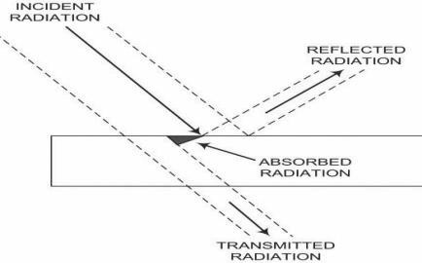

## Figure Long wave and shortwave radiation

The first law of thermodynamics: a + t + ρ = 1

# Where

**a** = fraction of incident radiation absorbed (absorptance).

**t** = fraction of incident radiation transmitted (transmittance).

**ρ** = fraction of incident radiation reflected (reflectance).

The floor surface is opaque, so the transmittance of the floor surface **t = 0**.

For a black surface where **a = 1**, **ρ = 0, t = 0**, all short-wave radiation reaching the surface will be absorbed by the black surface.

For most surfaces, absorptance for short-wave radiation (high-temperature radiation) is different than emittance for long-wave radiation (low- temperature radiation).

## Table - Absorptances for Solar Radiation

|  |  |
| --- | --- |
| Surfaces | Absorptance a for Solar  Radiation |
| Carpet — dark-colored | 0.80 — 0.90 |
| Carpet — light-colored | 0.50 — 0.60 |

|  |  |
| --- | --- |
| Tile or plaster, white or cream | 0.30 — 0.50 |
| Red tile, stone or concrete, dark paints | 0.65 — 0.80 |
| White-painted surfaces | 0.23 — 0.49 |

Solar absorptance can also vary with the size of windows. Absorptance can range from 0.90 for dark-colored spaces with small windows to 0.60 or less for light-colored spaces with large windows. When using textile-based floor coverings, the slab temperature required to draw down the floor surface temperature must be evaluated to ensure it does not approach the dew point temperature.

# CONCLUSION

During construction of the device several minor changes were made to the design. Each of these changes we feel was justified as they made for easier construction while maintaining the performance of the device with respect to the work goals. The device passed its final inspection and was deemed to have a professional appearance by the design work coordinator. The device was discovered to have ample precision and total heat transfer capabilities while meeting its accuracy requirement.

# REFERENCES

[1]. Reinhard Radermacher, Bao Yang, Integrating Alternative and Conventional Cooling Technologies, ASHRAE Journal, October 2007.

[2]. Jonathan Winkler, Potential Benefits of Thermoelectric Element Used With Air- Cooled Heat Exchangers, International Refrigeration and Air Conditioning Conference, 2006

[3]. Jonathan Schoenfeld, Integration of a Thermoelectric Subcooler Into a Carbon Dioxide Transcritical Vapor Compression Cycle Refrigeration System, International Refrigeration and Air Conditioning Conference,2008.

[4]. Michael Ralf Starke, Thermoelectrics for Cooling Power Electronics, The University of Tennessee, Knoxville,2006.

[5]. D. Astrain, J.G. Via´n, J. Albizua, Computational model for refrigerators based on Peltier effect application, Applied Thermal Engineering 25 (2005) 3149–3162.

[6]. Chakib Alaoui, Peltier Thermoelectric Modules Modeling and Evaluation, International Journal of Engineering (IJE), Volume (5) : Issue (1) : 2011

[7]. Tsung-Hsin Hung, Construction and Analysis of Personalized Air-conditioning System, National Chin Yi University of Technology, Taichung City 41170, Taiwan.

[8]. Limei Shen, Investigation of a novel thermoelectric radiant air-conditioning system, Energy and Buildings 59 (2013)

123–132.

[9]. Hyeung-Sik Choi, Development of a temperaturecontrolled car-seat system utilizing thermoelectric device, Applied Thermal Engineering 27 (2007) 2841–2849

[10]. Judith Koetzsch & Mark Madden, Thermoelectric Cooling for Industrial Enclosures, Rittal White Paper 304.